

Drowsiness Detection and Anti-Sleep Alarm System for Drivers

ENG4701: Final Year Project - Progress Report

Author(s): Ling Chen (31460593), Umar Abdullah Al Abedin (31199844)

Supervisor(s): Dr. Faezeh Marzbanrad

Date of Submission: 26/05/2023

Project type: Research

# Acknowledgement of Country

We wish to acknowledge the people of the Kulin Nations; on whose land we conducted this project. We wish to pay our respects to their Elders, past and present.

**Contents**

Acknowledgement of Country 2

1 Introduction 5

2 Aims and Objectives 6

2.1 Hypothesis 6

2.2 Aims 6

2.3 Objectives 6

3 Literature Review 7

3.1 Drowsiness Detection Methods 7

3.1.1 Subjective Measures 7

3.1.2 Vehicle-based Measures 8

3.1.3 Behavioural-based Measures 9

3.1.4 Physiological Measures 9

3.2 Classification Models for Drowsiness Detection 10

4 Methodology and Methods 12

4.1 Methodology 12

4.2 Methods 12

4.2.1 Participants 12

4.2.2 Procedure 12

4.2.2.1 Simulator Experiment Procedures 12

4.2.2.2 Passenger Seat Experiment Procedures 14

4.2.3 Feature Extraction and Data Analysis 14

4.2.3.1 Simulator Vehicular Features 14

4.2.3.2 Simulator Behavioural Features 15

4.2.3.3 Simulator Physiological Features 17

4.2.3.4 Summary of Simulation Features and Sources 17

4.2.3.5 Feature Selection 17

4.2.3.6 Classification 18

4.2.3.7 Passenger Seat Experiment Data Analysis 18

5 Project Progress 20

5.1 Preliminary results and discussion 20

5.1.1 Dataset Collection 20

5.1.2 Vehicle-based Feature Analysis 20

5.1.3 Behavioural-based Feature Analysis 22

5.2 Limitations and Future Work 25

5.2.1 Delays in obtaining recordings 25

5.2.2 Blinking and Yawning Detection inaccuracy 25

5.2.3 Error in Vehicular recording files 25

5.2.4 Future Work on Crash Detection 26

6 Scope, Project Plan & Timeline 27

6.1 Project Scope 27

6.2 Project Plan & Timeline 27

6.2.1 Project Plan 27

6.2.1.1 Phase 1: Research and Preparation 27

6.2.1.2 Phase 2: Data Collection 27

6.2.1.3 Data Analysis 28

6.2.1.4 Phase 4: Detection System 28

6.2.2 Timeline 28

6.3 Team Strategy and Work Breakdown 29

7 Risk Management Plan 31

8 Sustainability Plan 34

9 References 35

10 Appendices 39

10.1 Appendix A: Project Risk Assessment 39

10.2 Appendix B: Team Contract and Meeting Minutes 45

10.3 Appendix C: Simulator Settings 47

10.3.1 Config.cfg 47

10.3.2 Config_local.cfg 51

10.4 Appendix D: Work Breakdown Structure 54

10.5 Appendix E: Gantt Chart 55

10.6 Appendix F: AI Statement 56

# Introduction

Drowsiness is a state of feeling sleepy and lethargic. This occurs often in drivers travelling on high-speed highways during late night or afternoons [1]. Drowsiness caused by sleep deprivation can result in significantly reduced reaction times as well as mental impairment effects like having blood alcohol concentration (BAC) of 0.05-0.10% [2]. Furthermore, dozing off for just a few seconds is enough for vehicles to veer off uncontrollably at high speeds for over 100 metres. The combination of these factors causes a significant public safety concern, and it often results in devastating high speed road accidents. According to investigations by the U.S. Department of Transportation, 21% of fatal road accidents involved a drowsy driver [3]. Therefore, there is an urgent need for the research and development of a reliable system that detects drowsiness to prevent accidents.

Recent advances in technology, especially in machine learning methods, have led to an increased interest in research and development on drowsiness detection systems. There are three types of measures that are currently being used to monitor drowsiness. These include Vehicle-based measures, Behavioural measures, and Physiological measures [4]. Vehicle-based and behavioural measures are non-intrusive mostly and various methodologies have been adapted to analyse these measurements. Machine learning algorithms have been implemented in computer vision systems to monitor yawning and calculate Eye Aspect Ratio (EAR) in real-time [5] inside the car while the driver is driving. These methods work sometimes but are not reliable and robust enough to be used as a standalone system.

Continuing from prior research, this project will first focus on collecting data from a diverse set of participants using a selection of physiological and behaviour sensors which will then be analysed to extract features that correlate to drowsiness and then used to train a neural network model that is capable of detecting drowsiness in users in real time.

# Aims and Objectives

## Hypothesis

**Current State**

The drowsiness detection and alert systems in cars are unreliable, inaccurate, and not widely used.

**Impact**

This results to an increased risk of accidents which are caused by the driver’s impaired reaction time, attention, and judgement like having a BAC of 0.05-0.10% [2], as mentioned earlier. Drowsiness can lead to slower reflexes, decreased hazard perception, and reduced ability to make quick decisions while driving. These factors significantly increase the risk of accidents.

With no reliable way of being alerted while drowsy, severe drowsiness may cause them to fall asleep. This is extremely dangerous and can result in the loss of control over the vehicle, also leading to accidents.

**Desired State**

A reliable and accurate drowsiness detection and alerting system that is implemented or embedded in the cars or through a mobile application will reduce that probability of these accidents and make the drivers and other road users feel safer.

## Aims

This project aims to create a system that utilizes a combination of driver behavioural and physiological indicators to accurately detect drowsiness and alert the driver in a timely manner.

## Objectives

To accomplish this aim, several key milestones have been identified that must be achieved by the end of the year. These include:

1. Use the selected vehicle/behavioural/physiological sensors to collect data from 20 participants of diverse background in two separate experiments:
   1. The first experiment will be conducted in a research laboratory where participants’ data will be collected as they operate a virtual driving simulator in three different time periods:
      1. Morning sessions: **9-11am**
      2. Afternoon sessions: **3-5pm**
      3. Night sessions: **3-5am**
   2. The second experiment will be conducted in a vehicle where the participants’ data will be collected as they are being driven in the passenger seat.
2. Process and clean the collected data using conventional noise filtering methods.
3. Analyse the measurement data to extract features from the behavioural/physiological data that correlate to drowsiness.
4. Determine the relevance of the features to select the most important ones and implement algorithms to extract them.
5. Use the discovered features to train a Neural Network classifier that will be able to automatically detect drowsiness by analysing sensor data in real time.
6. Implement a software system using a Raspberry Pi and relevant modules or a phone application to alert the driver when signs of drowsiness are detected.

# Literature Review

## Drowsiness Detection Methods

Drowsiness refers to an inclination of falling asleep. The state of being drowsy can lead to several impairments such as inhibited cognition, reaction speed and loss of control and driving while being in this state drastically increases the potential for accidents. However, drivers do not just suddenly become drowsy, there is a slow transition period where the sign of drowsiness becomes more and more prominent as the drowsiness level increases, therefore it is possible to develop a system capable of alerting the driver during early stages of drowsiness to prevent accidents.

A survey conducted by Nordebakke et al. [6] found that some signs common to all genders were:

* Difficulty in keeping eyes open.
* Yawning.
* More frequent blinking.

The above physical behavioural signs along with other physiological signs of drowsiness have been widely utilised by researchers to develop drowsiness detection systems. In general, most recent works have mainly adapted five categories of measures to determine driver drowsiness [4, 7].

The block diagram in figure 3.1.1 shows all the different types of detection measures that have been considered in driver drowsiness detection research.

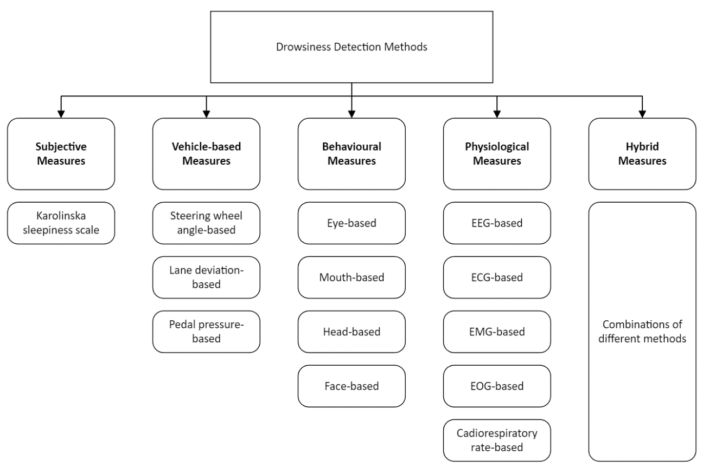

Figure 3.1.1: Different types of methods for Driver Drowsiness Detection Systems

### Subjective Measures

Subjective measures refer to using the driver’s personal estimation as an indication to the level of drowsiness that is being experienced by them. The most used scale is the nine-point Karolinska Sleepiness Scale which is elaborated in table 3.1.1.1 [4].

Table 3.1.1.1: Karolinska Sleepiness Scale (KSS)

|  |  |
| --- | --- |
| **KSS Rating** | **Verbal descriptions** |
| 1 | Extremely alert |
| 2 | Very alert |
| 3 | Alert |
| 4 | Fairly alert |
| 5 | Neither alert nor sleepy |
| 6 | Some signs of sleepiness |
| 7 | Sleepy, but no effort to keep alert |
| 8 | Sleepy, some effort to keep alert |
| 9 | Very sleepy, great effort to keep alert, fighting sleep |

A technique that uses this scale measures the KSS ratings of drivers every 5 minutes and compares it with measurements taken from all vehicle-based, behavioural, and physiological measure. It was found that there was no strong evidence of correlation between any of the measures with the KSS ratings of drivers [4]. The measurements were taken in 5-minute intervals and sudden variations in ratings cannot be detected. Additionally, the idea of rating themselves alerts the drivers and so the measurements cannot be relied upon since they do not match the conditions experienced by drivers in real driving situations. For these reasons, using subjective measures alone has been evaluated to be very unreliable and not conclusive enough to serve the purposes of this study.

### Vehicle-based Measures

The monitoring points used for vehicle-based measures include measuring the steering wheel movements (SWM), standard deviation of lane position (SDLP), and, less commonly, pressure on acceleration pedals [4, 8]. These experiments are usually conducted in a simulator environment where various sensors are embedded into monitoring these.

When monitoring the SWM, small angle of rotations, usually between 0.5-5 degrees, are measured since it was found that when drowsy, drivers tend to make less micro-corrections on the driving wheel [8, 9]. This way, SWM can be used to monitor for driver drowsiness. However, car companies such as Nissan and Renault have attempted to adapt this technique into their cars and discovered that the system works in strict conditions as road structures and environmental differences are significant contributors to false positive results [10].

Similarly, the SDLP is monitored using cameras recording the lane in real driving situations or from the simulator itself if a simulator environment is used [11]. Drowsy drivers tend to find it difficult to remain centrally in lane while travelling along a curving road. There is evidence of positive correlation between KSS ratings provided by drivers and the SDLP, however, it was found that these varied significant on a participant-to-participant basis. The SDLP was also observed to vary when the driver is under influence of other condition excluding drowsiness, for example, depressants or alcohol [12].

Vehicle-based measures cannot be used as a standalone measure to detect drowsiness due to the limitations described above. Both the SWM and SDLP are inconsistent methods and must be used in conjunction with other measures to be discussed, so that the drowsiness can be reliably measured.

### Behavioural-based Measures

Image based drowsiness detection techniques are used to detect behavioural changes that happen during the state of drowsiness. Recently researched work included yawning detection, thermal respiration detection, eye tracking/eyelid closure analysis, head posture detection and general face expression analysis [4, 13]. These behaviour detection methods often only require data from different types of cameras, and video and image analysis are performed to detect changes in facial features and driver posture. Due to the widespread use of smart phones and dash cams, video and image data are extremely accessible, which is beneficial to both development and deployment. Therefore, good behaviour detection-based systems are often very desirable especially because they are also non-intrusive and non-invasive.

Analysis of eye features is one detection method that has been extensively studied. One proposed method explored by Khan et al. [14] is to analyse curvature of the eyelid to determine whether the driver’s eyes are closed or not. Although they achieved an average classification accuracy of 95% on simple scenes, the algorithm struggles with 70% accuracy on more complex scenes. Similar works on eye closure analysis include research by Horng et al. [15], where edge detection and pixel colour value matching were used to detect eye closure based on whether the eyeballs were visible.  Both detection methods relied on checking for prolonged periods of eyelid closure, but this is often too late for effective accident prevention in high-speed situations.

An alternative ocular method that has been studied is blinking analysis. In early stages of drowsiness, both blinking frequency and blink duration are increased. This makes detection systems based on blinking analysis preferable for early drowsiness detection. Some relevant work include work done by Maior et al. [16] and Rahman et al. [17], where Eye Aspect Ratio (EAR) and corner detection were used respectively to determine eye state. Furthermore, blinking rate alone is often not conclusive enough due to possible outliers caused by conditions like dry eyes, and several other metrics such as change in blink velocity/duration could have been used in conjunction.

Another logical behavioural pattern that can be used for drowsiness detection is yawning detection. One popular method is performing face extract and mouth detection using computer vision techniques, and then performing classification using Support Vector Machine (SVM) [18]. Another notable method utilises thermal images to detect yawning by looking for temperature anomalies near the mouth region [19]. Although both works can detect the presence of an open mouth, the systems fail to detect gentle yawns with narrow mouth openings resulting in many false negatives. The works also only focus on solo drivers and does not account for the presence of talking and laughing, which may result in a lot of false positive detection in a real car environment.

Overall, behavioural analysis through image/video-based detection can achieve high detection accuracies. However, due to obvious limitations and performance drops due to factors such as, varying lighting conditions, presence of face wear and long facial hair, using these techniques as the standalone detection method is not ideal. Taking this into consideration, this project will take a more hybrid approach, focusing on detection of early signs of drowsiness, while matching it with other measurements to ensure reliability of detection.

### Physiological Measures

Monitoring the physiological state of a driver is the most reliable method of identifying even the early signs of drowsiness. The main signals that researchers record is electrooculogram (EOG), electrocardiogram (ECG), electroencephalogram (EEG), electromyogram (EMG), and respiratory signals [13]. All these methods include attaching sensors at various parts of the participant’s body and measuring the signals while the participant is driving.

EOG uses electrodes placed at the outer corner of each eye and another one at the centre of the forehead to measure the electric field generated by a potential difference between the cornea and the retina. REM and Slow Eye Movements (SEM) that occur when a person is drowsy can be measured using this technique [20]. EOG is very rarely used due to the highly intrusive nature of the data collection and will not be used in this project for this reason as well.

The heart rate (HR) or the heart rate variability (HRV) are easily measured using the ECG electrodes and these can be used to determine the drowsiness of a driver since they vary greatly based on the different stages of drowsiness such as alertness and fatigue [21]. When using HRV, the low (LF) and high (HF) are measured which fall in the range of 0.04-0.15Hz and 0.14-0.4Hz respectively [22]. These are the beat-to-beat (R R intervals) changes in HR and the ratio of LF to HF decreases as a driver becomes drowsy [23]. These methods of monitoring the HR are intrusive and as such another non-invasive way to monitor HR is Ballistocardiograph (BCG). The technique involves measuring the degree of movement produced by a heartbeat by placing electrodes on the seat. While BCG works well in stationary systems [24], there are difficulties using it in cars due to the motion of the car and bumpy road creating noise, however, traditional filtering techniques have been used and are found to work well with BCG measurements. As such, both ECG and BCG techniques are adapted in this project due to their high reliability.

EEG is the most common physiological signal used to detect drowsiness. It measures the activity of the brain using electrodes. Mainly two different frequency bands are observed when determining drowsiness using this technique. There are the delta band between 0.5-4Hz that correspond to the sleep activity and the theta band between 4-8Hz that correspond to drowsiness. An increase in intensity of signals in these wavebands indicate drowsiness [25]. This technique will be significantly used in this project due to its accuracy and reliability.

EMG is the measure of the electrical activity generated by the body’s muscle during contraction. It was found that both the intensity and frequency of the signals generated by the contraction decrease when a driver is drowsy [26]. Thus, the changes in EMG signal intensity and frequency can serve as indicators of drowsiness.

Finally, the method of measuring the respiration rate measures the number of breaths taken per minute and it is also an important physiological parameter that indicates drowsiness. During drowsiness, respiration rate tends to decrease, indicating a reduction in the rate of breathing [27]. Breathing rate extraction via this method is challenging in a vehicle as the sensor picks up the vehicle's acceleration and deceleration rather than the breathing rate. Thus, filtering out these noises is necessary to obtain the driver's breathing rate. This filtering process will be explored in the project by using a reference sensor to perform noise cancellation.

Considering the described methods and their benefits, the utilization of physiological signals as an indicator of drowsiness has been assessed as considerably significant and valuable for the project's objectives. Consequently, they will be utilized alongside other vehicle-based and behavioural measures detailed earlier, to develop a highly resilient and precise drowsiness detection system.

## Classification Models for Drowsiness Detection

To successfully perform drowsiness detection, a reliable and appropriate classification model must be used at the final step of the process. The role of a classification model is to perform the decision-making step to determine whether a driver is in a state of drowsiness or not, by considering all the input parameters and information. However, depending on the input data type, some methods may be more suitable than others.

The most prominent classification models that have been used in recent drowsiness detection research include:

* Logistic Regression (LR)
* Support Vector Machine (SVM)
* (Deep) Convolutional Neural Network (CNN/DCNN)
* Artificial Neural Network (ANN)
* Long Short-Term Memory Networks (LSTM)

Logistic regression is a statistical model used for binary classification. It can find the ideal linear decision boundary within the data. In past research by Babaeian et al. [28], they utilised a LR classifier to differentiate between alert and drowsy ECG data. Although this type of model is simple, easy to understand and computationally inexpensive, a linear decision boundary may not be able to effectively separate complex data that have non-linear relationships. In comparison, Support Vector Machine method also determines a decision boundary for the data but may be more suitable for non-linear relationships as it can use kernel functions to map input data into higher-dimensional feature space. In work by Kumar et al. [29], SVM was used to efficiently perform classification with 3 features, EAR, Mouth Opening Ratio (MOR) and Nose Length Ratio (NLR).

In terms of behavioural data from images, hand crafted feature extractors like ones used by Kumar et al. may be difficult to implement, which provides motivation for the use of the state-of-the-art Convolutional Neural Networks for image and video data. CNNs uses a series of convolutional layers to automatically learn spatial information and detect important features in images to maximise prediction accuracy. Various works showcase the effectiveness of CNNs in drowsiness detection [30, 31], demonstrating that this architecture often outperforms other methods. Although recent works using this architecture were able to achieve very high accuracies, training such a model requires tremendous amount of labelled training image data, which may be very time consuming to manually collect and annotate. Although CNNs perform well for behavioural analysis based on images, it is still unsuitable for classifying physiological and vehicular data that will be used for this project.

A more suitable method to classify numerical data such as physiological signals (EEG, ECG, EMG) and vehicular signals (SWM) is using Artificial Neural Networks such as Multi-Layered Perceptron (MLP). Hasan et al. [32] demonstrates the usage of ANNs for classification of physiological signals, showing that it outperforms simpler classifiers such as LR and SVM. Furthermore, once facial features get quantified using EAR, MOR or NLR, these can also be classified using ANNs to achieve better results than using SVM method [33].

In terms of drowsiness detection, a recurring problem is that it is often difficult to predict the drowsiness level of the driver based on just one instance of data, hence Recurrent Neural Networks like LSTM are often used to make prediction based on a sequence of data/image frames. Yarlagadda et al. in their work used LSTM in conjunction with CNN to perform classification across a consecutive number of frames, achieving 97.20% accuracy. [34] However, in their proposed method, only behavioural data in the form of face recording was considered, and their method does not consider the use of physiological and vehicular features to increase accuracy.

The above analysis suggests that for hybrid-based approaches like this project, it is often not enough to only use a single classification model. In this project, ANN will be primarily used for classification as it provides the ability to work with all the collected data, however a LTSM-CNN based model will also be explored for behaviour analysis due to its effectiveness for video/image classification.

# Methodology and Methods

## Methodology

From the literature review conducted, this project falls into the category of quantitative research. Quantitative research refers to the collection of numerical data through standardized and structured tests, experiments, and simulations, and analysing it to test a hypothesis.

20 participants will be recruited, and various Vehicle-based, Physiological and Behavioural signals will be collected from them. A detailed description of what sensors will be used to take the measurements is provided in methods below and a combination of these measurements will be used to make a detection system. All these measurements are quantifiable and, as discussed earlier, these methods generate quantitative data that can be analysed statistically to determine patterns and trends within the data.

## Methods

### Participants

Participants will be recruited through online advertisements and will include 20 healthy adults aged from 20 years old and onwards and who are holding a driver licence (including probationary and international licences).

### Procedure

A full explanation document will be provided to participants that ensures the confidentiality of measurements and details the risks that may be posed. They will be required to sign a consent form. There are also pre-experiment and post-experiment surveys that collect information about their sleep cycles and their experience with the experiment respectively. There are two experiments that participants will be asked to partake in:

1. Simulator experiment where participants will be simulating driving in a selected simulator and various sensors (physiological, behavioural, vehicular) will taking measurements while they drive.
2. Passenger seat experiment where participants will have cardiorespiratory related sensors attached that take measurements as they are being driven around.

#### Simulator Experiment Procedures

The simulator experiment will be used to collect a complete set of data including ECG, EEG, EMG, Face recording, Simulator (dash cam) recording, Steering wheel angle and Pedal/Brake positions. These data will be used for feature selection and serve as training/validation data for a machine learning based drowsiness detection system.

Participants will be asked to record their data in 30-minute blocks in three sessions between:

* Morning sessions:**9-11am**
* Afternoon sessions: **3-5pm**
* Night sessions: **3-5am**

Participants will also be required to remain in the laboratory to ensure they do not fall asleep from 11pm until the late-night experiment.

The simulator used is Euro Truck Simulator 2 with a mod that changes the driving vehicle to a Toyota Corolla 2018 to have a more accurate immersive experience. The session the experiment is conducted in will be reflected in the simulator as well by changing the time in developer mode. A perspective of the participant while driving in the simulator is shown in figure 4.2.2.1.1.

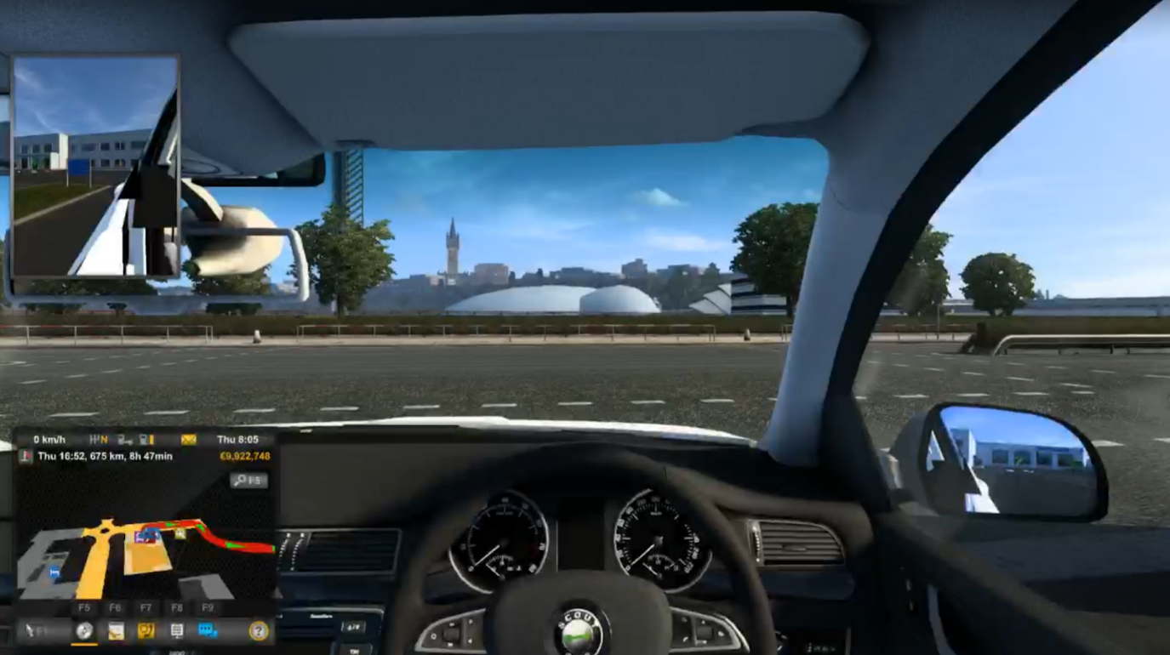

Figure 4.2.2.1.1: Simulator view

There is a pre-set destination that the participants can drive to by following the GPS map in the simulator and it would take 30 minutes. Participants will be using the Logitech G29 Driving Force that has a steering wheel, gear change functionality, and acceleration and braking pedals while driving. A lot of simulation parameters in the simulator settings have been modified. A detailed list of the settings and their values is given in Appendix C: Simulator settings.

A screen recording software is used to record the driving of the participants which will be later processed to determine standard deviation of lane position. A python script will be executed that will measure the steering wheel rotations and record the participant using a webcam that will be later processed for EAR, blinking rate, yawning, and head movement.

To obtain recordings for physiological signals, the participant will have EEG, ECG and EMG sensors attached to them. The EEG hardware used is an OpenBCI electrode cap and the ECG/EMG hardware used are general ECG/EMG snap electrode cables and skin tact sticky electrodes. For EMG, the forearm muscle is used for the measurements. The figure 4.2.2.1.2 shows where to connect the electrodes for the forearm. These are interfaced with the OpenBCI Cyton Board + Daisy Board which connects to a Cyton Bluetooth USB dongle connected to a computer. The computer will require the OpenBCI GUI software to be able to obtain the measurements from the dongle. A detailed guide on how to interface these sensors is provided by OpenBCI in their website [35].

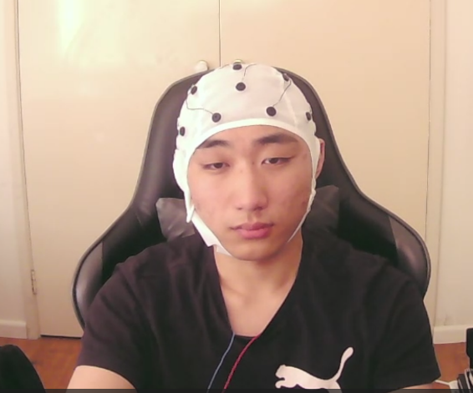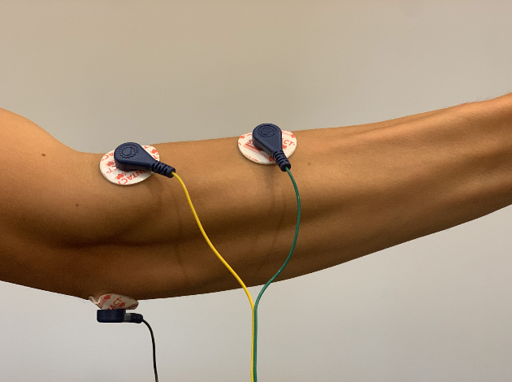

Figure 4.2.2.1.2: EEG cap (left) and EMG connections (right)

These programs and software are run before the participant begins driving and they will continuously collect data for 30 minutes after which point the programs will be set to stop recording data. These processes are repeated for each session.

#### Passenger Seat Experiment Procedures

The Passenger seat experiment will be used to evaluate the practicality and effectiveness of a non-intrusive BCG seat for measuring cardiorespiratory signals.

Participants will be sitting on the passenger seat of a car. The experiment will require a total of 10-15 minutes and will measure BCG signals, and respiration rate using a pair of accelerometers.

The participants will first be asked to assist with the calibration of the sensors as necessary (e.g., adjusting their seat position to accommodate the sensor placements) prior to driving. An accelerometer will be attached to the seatbelt of the participant and another to the base of the seat and their measurements will be used to determine the respiration rate of the participant.

There are seven piezoelectric sensors embedded into the seat that are intended to measure BCG signals of the participant. These measurements will be used to determine their HR.

The piezoelectric sensors and the pair of accelerometers will be interfaced via a Raspberry Pi which will store the measured data for processing in an SD card. The setup of the passenger seat is shown in figure 4.2.2.2.1.

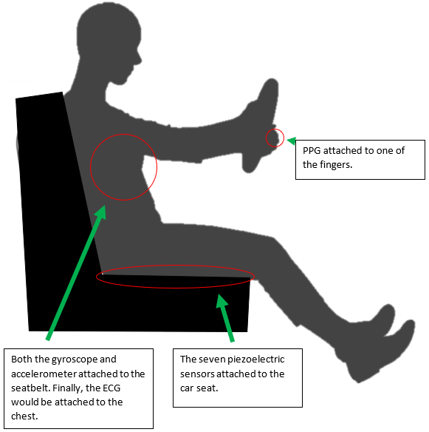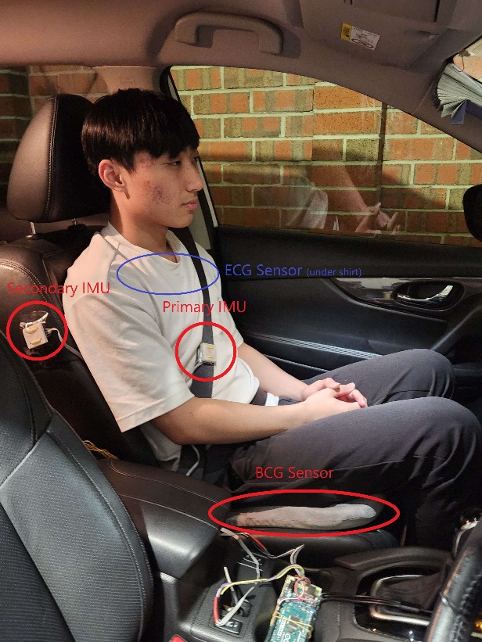

Figure 4.2.2.2.1: Sensors for passenger seat experiment

### Feature Extraction and Data Analysis

#### Simulator Vehicular Features

The recording of the screen where the participant is driving in the simulator will be used to determine lane position. This is done using a lane detection program using computer vision that has been adapted from a blog in Automatic Addison [36]. The general process is described as follows:

1. Apply a binary thresholding to isolate the pixels that represent lane lines.
2. Apply perspective transformation to obtain Bird’s Eye View.
3. Identify lane line pixels
4. Fill in the lane line
5. Overlay lane line on original image
6. Calculate lane line curvature
7. Calculate centre offset

For the steering wheel rotation data, it will first be processed to filter out all rotations that are greater than 5 degrees since the area of interest is to check for micro-corrections between 0.5-5 degrees. After the filtering of the data, whenever there is a rotation of the steering wheel between 0.5-5 degrees in the dataset, a corresponding rotation in the opposite direction within the next few hundred milliseconds will be searched for using a search algorithm. The frequency of this micro-correction will then be measured to obtain a frequency domain plot of the micro-corrections. The intensity and frequency of this will then be compared between the those of the three different sessions and inferential statistics, such as correlation analysis, will be implemented to identify associations between drowsiness and the frequency of micro-corrections of the steering wheel.

#### Simulator Behavioural Features

Existing computer vision techniques will be used to determine each of features to be extracted from the webcam recording. A popular and well explored face mesh extraction library, MediaPipe, will be used to first extract the 478 3D facial landmark positions which can be used to calculate various facial features such as EAR, MOR and NLR [30]. MediaPipe uses light weight machine learning models to efficiently infer 3D face surface from just a single camera, which is critical for performing real-time drowsiness detection [37, 38]. A diagram of the facial landmarks is shown in Figure 4.2.3.2.1.

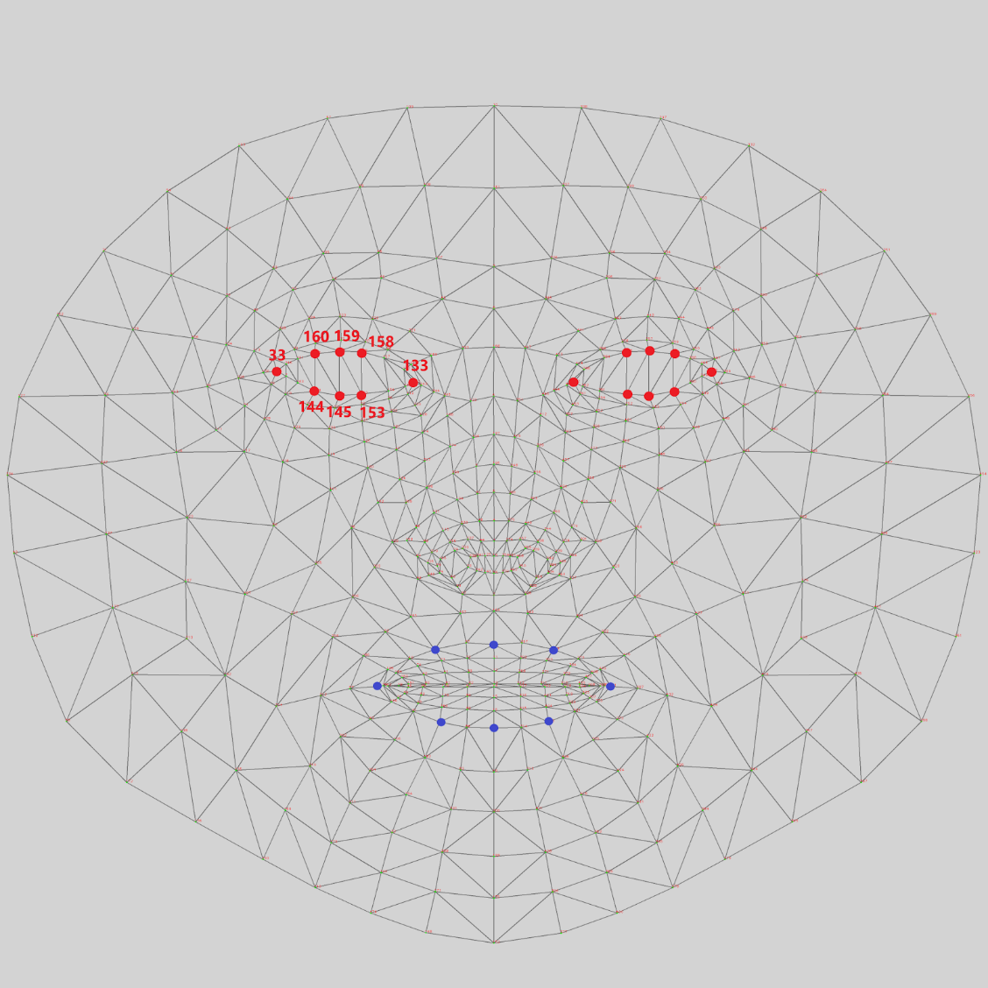

Figure 4.2.3.2.1: Diagram of MediaPipe face mesh coordinates [39]

From the obtained face mesh landmarks, hand crafted features like EAR, MOR, pupil circularity (PuC) as well as head tilt and position will be extracted. The method used will be based on previous works such as ones by Rahman et al and Kumar et al [40, 41, 17, 29], and the equation used to calculate the EAR is shown equation 1 and 2. Afterwards, several auxiliary features based on the EAR/MOR values will be extracted for analysis, including average and change in blinking rate, change in eye closeness, blinking velocity/duration and yawning. These parameters will be statistically analysed against independent variables such as time of recording (morning, afternoon, late night) and KSS drowsiness levels and T-tests as well as F-tests will be performed appropriately to evaluate the statistical significance and usefulness of these parameters in detecting drowsiness.

$EAR= \frac{\left\|P2-P6\right\|+\left\|P3-P5\right\| }{2\left\|P1-P4\right\|}$ (1)

$Ear_{AVG}=\frac{1}{2}(EAR_{left}+EAR_{right})$ (2)

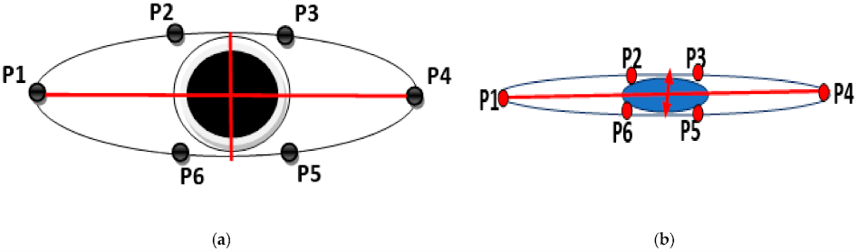

Figure 4.2.3.2.1: EAR Calculation [40]

Additionally, more abstract features will also be extracted using existing pre-trained machine learning models like ResNet and VGGNet detailed by Dua et al and Anber et al [42, 43]. Transfer learning these models will be performed on our own collected dataset of face recordings to fine tune it for improved accuracy. Publicly available drowsiness detection video datasets such as DROZY [44] and National Tsing Hua University (NTHU) [45] will also be used for more training data if necessary.

#### Simulator Physiological Features

For the physiological measurements, the OpenBCI GUI formats the measured data into their respective channels as connected to the Cyton Board and provides timestamps for every individual measurement and saves it in both a text file format and an excel sheet format. The methodology used is adapted from [46]. The measurements are first filtered using bandpass filters. Features will then be extracted across the different window frames, 15 and 30 seconds. The features that are extracted are shown in table _ below. Statistical tests like the Shapiro-Wilk test and T-tests will be used. The data will be normalized per participant and split into 70% training and 30% fine-tuning sets. Feature selection will be done using "SelectKbest" with an ANOVA F-value scoring function. Additionally, K-Nearest Neighbours will also be used to classify and group the features to look for useful patterns.

#### Summary of Simulation Features and Sources

Table 4.2.3.4.1: Summary of features

|  |  |
| --- | --- |
| **Source** | **Features** |
| Simulator | Steering Angle, Mean/Standard Deviation of Steering Angle, Mean Lane Position |
| Face recording | Full Facial Landmarks, Eye Aspect Ratio (EAR), Blinking Rate, Blink Duration, Eye Closeness, Mouth Aspect Ratio (MAR), Yawning, Pupil Circularity (PuC), Head Tilt/Position |
| EEG | Delta Power (0.5-4 Hz), Theta Power (4-7 Hz), Alpha Power (8-12 Hz), Beta Power (12.5-16 Hz), Wavelet Entropy, Mean/Median, Standard Deviation |
| EMG | Mean, Median, Variance, Low Frequency (1-15 Hz), Medium Frequency (15-30 Hz), High Frequency (30-50 Hz) |
| ECG | Heart Rate (HR), Very Low Frequency (VLF) (0.003-0.04 Hz), Low Frequency (LF) (0.04-0.15 Hz), High Frequency (HF) (0.15-0.40), LF/HF Ratio, Power, Respiration Rate, Median Respiration Rate Variability |

#### Feature Selection

In this section, we discuss three important approaches for feature selection and reduction: maximum relevance, minimum redundancy, and statistical significance.

Maximum relevance aims to select features that have the highest correlation with the target variable, in this case, the drowsiness state of drivers. The idea is to identify features that are most informative and directly contribute to the prediction task. Various techniques can be employed to measure the relevance of features, such as correlation coefficients, mutual information, or information gain. By selecting features with high relevance, we can focus on the most significant factors that influence drowsiness.

While selecting relevant features is important, it is equally crucial to minimize redundancy among them. Redundant features provide similar information and may not add much value to the predictive model. Reducing redundancy helps to improve model interpretability, reduce overfitting, and enhance computational efficiency. Techniques like correlation analysis, variance inflation factor, or principal component analysis (PCA) can be employed to identify and remove redundant features.

In addition to the relevance and redundancy considerations, we can also utilize statistical tests to determine the significance of individual features in predicting drowsiness. These tests assess the statistical relationship between each feature and the target variable. Features that demonstrate a significant association or difference after conducting appropriate statistical tests, such as t-tests, ANOVA, or chi-square tests, can be considered for inclusion in the final feature set. This approach helps us identify features that have a strong statistical impact on the drowsiness prediction task.

#### Classification

A machine learning based predictive classification model will be developed using the processed data as well as the above extracted features in Table 4.2.3.4.1 as input. As reviewed in section 3.1, the most accurate architectures used in recent work utilizes ANNs to classify physiological data and numerical hand extract features like EAR, and CNNs to perform prediction directly on the face image frames. Also, to account for temporal information a LSTM architecture instead of ANN will also be experimented [34]. The proposed process/architecture is shown in the diagram in Figure 4.2.3.6.1.

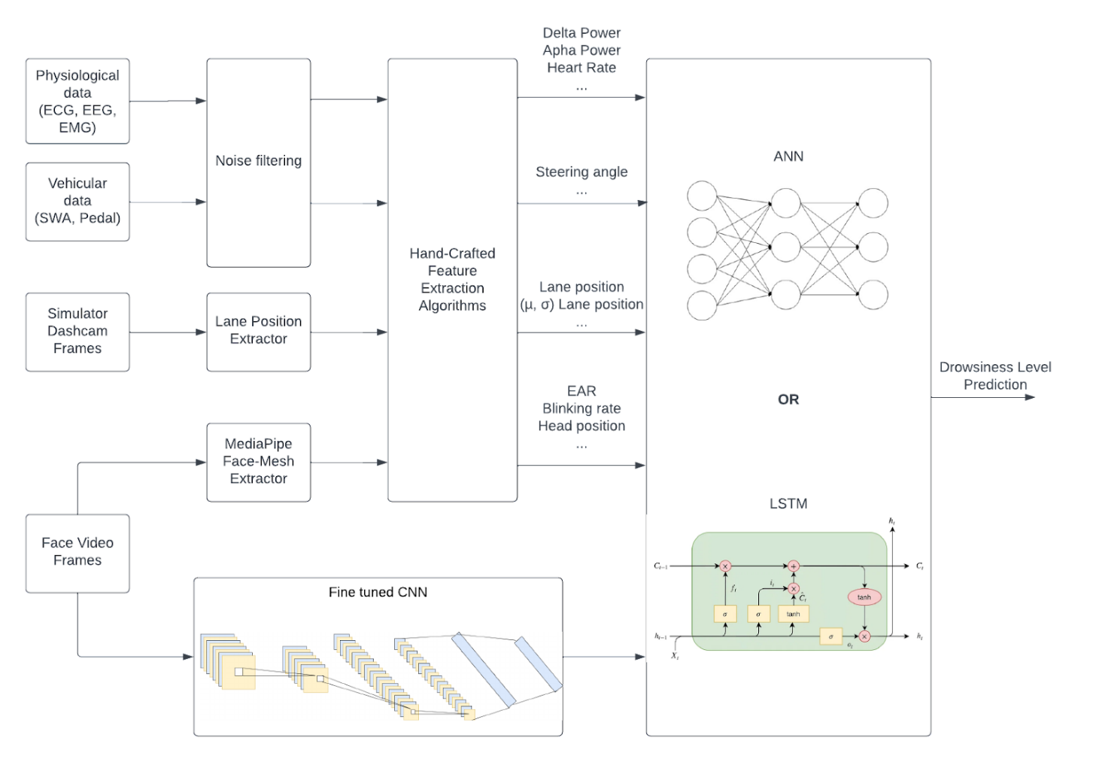

Figure 4.2.3.6.1: Proposed process and architecture diagram

A pre-trained CNN model will be utilized to start from a decent baseline feature extractor, then fine tuning will be performed to make it more specialised for this project. The data will be randomly divided into a training set and a validation set. The training set will be used to train the machine learning algorithms, and the validation set will be used to test the performance of the model.

#### Passenger Seat Experiment Data Analysis

In the passenger seat experiment, the measured BCG data will be processed through the filters developed already in the project to obtain HR data. Similarly, the accelerometer data will also be filtered using the developed filters to obtain a measure of the respiration rate. The detection system or parameters obtained from the measurements in the simulation experiment will be used in conjunction with these measurements to determine the heart rate of the participant accurately.

Overall, this study will provide valuable insights into the use of quantitative methods to detect drowsiness in drivers. The results of this study may inform the development of non-invasive and reliable technologies for detecting drowsiness and reducing the risk of accidents caused by drowsy driving.

# Project Progress

## Preliminary results and discussion

### Dataset Collection

From procedures described in section 4.2.2.1, a sizeable set of simulator experiment data has been collected. In total, 14 sets of morning, afternoon and night data from different participants have been compiled so far, each containing 30 minutes of the following data:

* 1080p face recording
* 1080p simulator recording
* EEG, ECG and EMG data
* Steering wheel angle, pedal, and brake positions
* Before and after KSS survey

More data for the simulator experiment will be collected in future works to ensure a diverse and complete dataset.

Some data for the passenger seat experiment has been collected, but there are not enough for in depth analysis, therefore the data collection will continue for this experiment.

### Vehicle-based Feature Analysis

The program with the algorithm described in section 4.2.3.1 has been run on a few screenshots taken from the simulation video. The thresholding step will be discussed in further details here to explain the process of detecting the lanes and calculating the lane position. An example frame is shown in figure 5.1.2.1 (a).

The image space is initially converted to Hue, Saturation, and Lightness since it is better the BGR colour space for detecting image issues due to lighting. Afterwards, Sobel Edge Detection is performed on the Lightness channel of the image to detect sharp discontinuities in the pixel intensities which would be apparent for the white lane markers. Binary Thresholding is then performed on the Saturation channel. Lane lines are expected to be solid white lines which have high saturation values. The threshold value of the saturation is required to be fine-tuned to ensure the lanes are obtained for the recorded video. Binary Thresholding is again performed on the image on the red channel in the BGR space to obtain the lanes. Bitwise AND operation is performed on these two images to obtain the image shown in figure 5.1.2.1 (b).

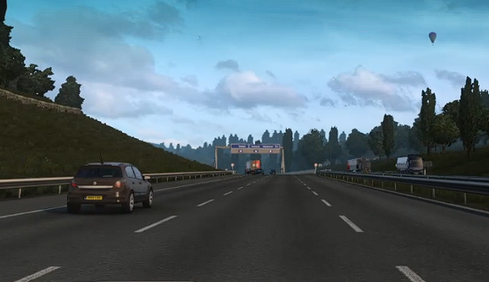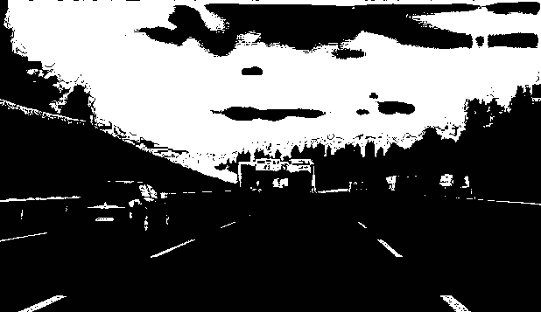

Figure 5.1.2.1: (a) original image (left), and (b) Image after final bitwise AND operation (right)

The remainder of the algorithm is then implemented on the image shown in fig 5.1.2.1 (a) to obtain the result as shown in figure 5.1.2.2 (a). The green area highlighted in the image is the estimated lane that the car is driving in. It is very inaccurate.

This inaccuracy is because the image being fed into the algorithm to compute the lane position is being cropped from the frame of the video. The frame is shown in figure 5.1.2.3. This leads to the quality of the cropped image being very poor and due to the limitations of the simulator, the lane markers are not white enough to be captured properly by the program.

To compensate for this, the image has been processed with various parameters. The brightness, contrast, brilliance, saturation, sharpness, definition, and black point have been increased and the shadows and noise have been decreased.

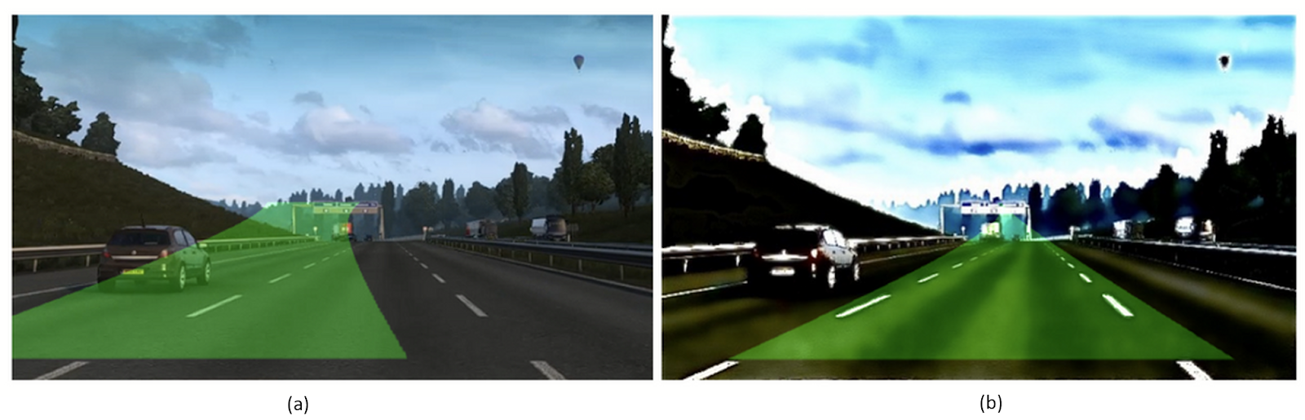

Figure 5.1.2.2: Lane estimation (a) incorrect, (b) correct.

Figure 5.1.2.2 (b) shows the lane being captured by the program accurately. This lane offset is calculated for every frame in the video. A window frame of 2 seconds is used, and the mean lane offset, and standard deviation is determined for each window for every run. Figure 5.1.2.4 shows how the mean offset per window varies with time.

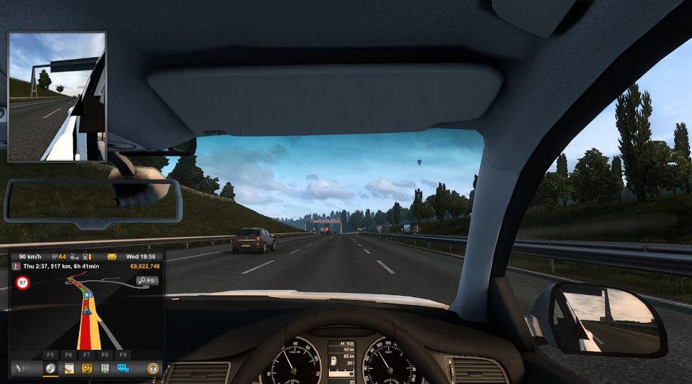

Figure 5.1.2.3: Actual screenshot of frame from recording

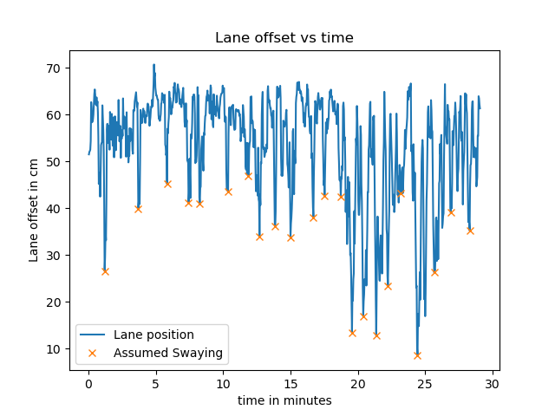

Figure 5.1.2.4: Variation of lane offset per frame over time

The data is from a participant with a KSS 10 rating. An average offset of 60cm exists due to the lane being recorded from the driver’s seat. The program used is not very resilient which is why there seems to be a lot of noise. The video has also been clipped slightly to only show recording for when the driver is on the highway.

After the 18-minute mark, however, the day cycles to night-time and due to the limitations of the program, the program is not accurately able to determine the lane position. The standard deviation of lane position has been determined as well in the for the 2 second windows, however, the measurements are very unstable even when the car is driven straight at the centre of the lane. The graph for standard deviation vs time is shown in figure 5.1.2.5.

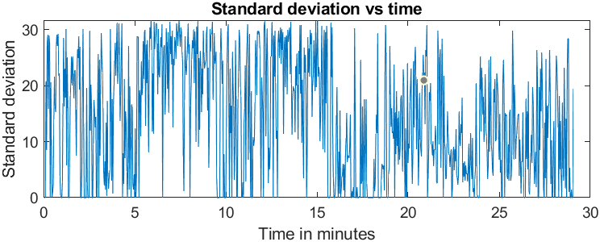

Figure 5.1.2.5: Change in standard deviation per frame with time

It takes very long to process each simulation video and then run the program. This time constraint inhibited the analysis of more videos and as such it was not possible to extract these features from more data. Further work includes processing and extracting these features from every video and then performing the statistical tests described earlier along with behavioural and physiological data.

### Behavioural-based Feature Analysis

As described 4.2.3.2, the face mesh coordinates are first extracted from the face recordings using the MediaPipe library in Python. From these 3D landmark positions, various features such as Eye Aspect Ratio (EAR), Mouth Aspect Ratio (MAR), Pupil Circularity (PuC) and Head Tilt were calculated. The face mesh extracted from each frame from the videos are shown in Figure 5.1.3.1.

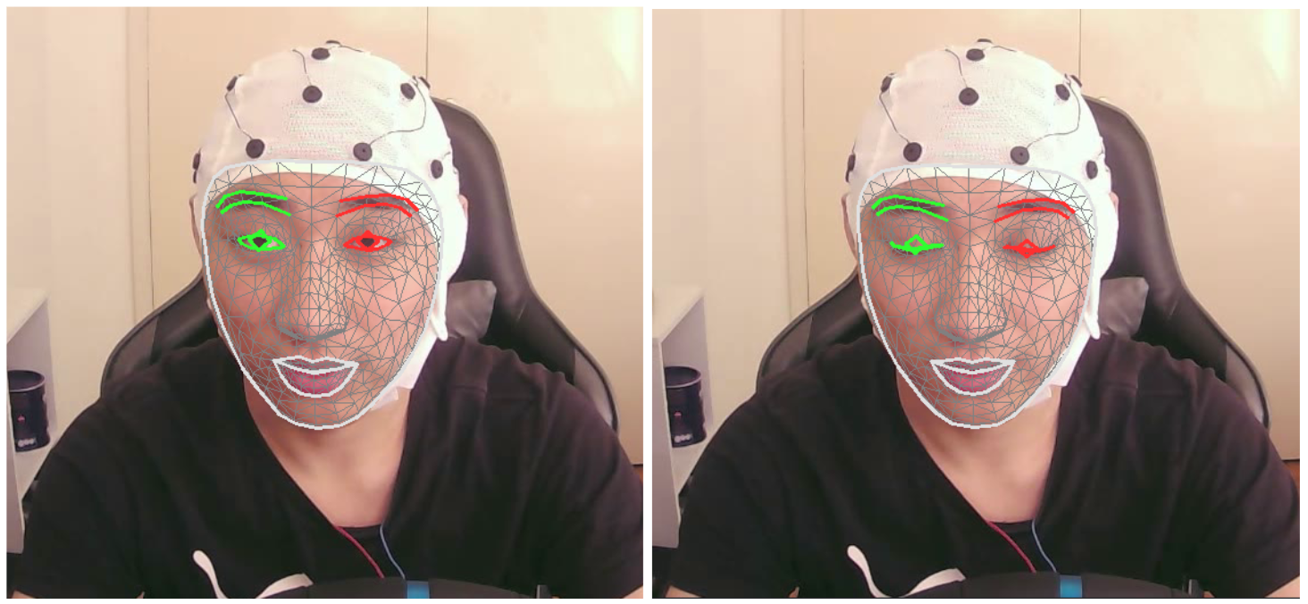

Figure 5.1.3.1: Face mesh extracted using MediaPipe

From the extracted EAR values, instances of blinks were determined using a peak finding algorithm. As shown in Figure 5.1.3.2, blinks can be identified by a sharp drop and rise in the EAR value. Using this method, the average blinking rate over a period can be calculated by the total amount of blinks divided by time. Additionally, by removing these dips/blinks, the average eye openness can also be obtained.

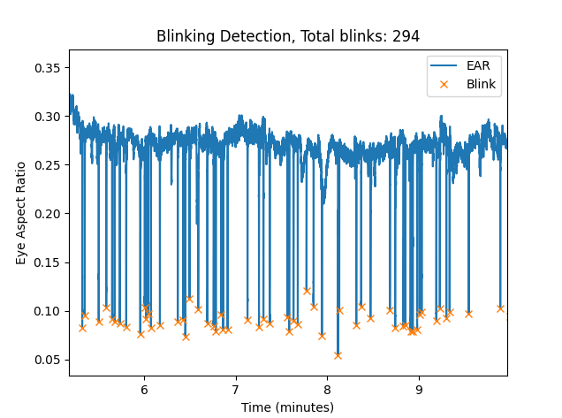

Figure 5.1.3.2: Example of blinking detection from EAR Plot

To determine the usefulness of EAR in drowsiness detection, the blinking rate and EAR over time of alert and drowsy participants were compared. Figure 5.1.3.3 shows these EAR related parameters for an alert (KSS-2) participant and Figure 5.1.3.4 shows the graphs for an extremely drowsy participant (KSS-10) that was also analysed in section 5.1.2.1.

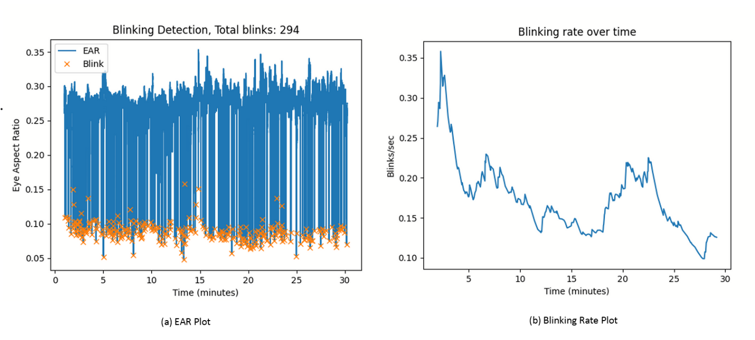

Figure 5.1.3.3: EAR and blinking rate for alert driver

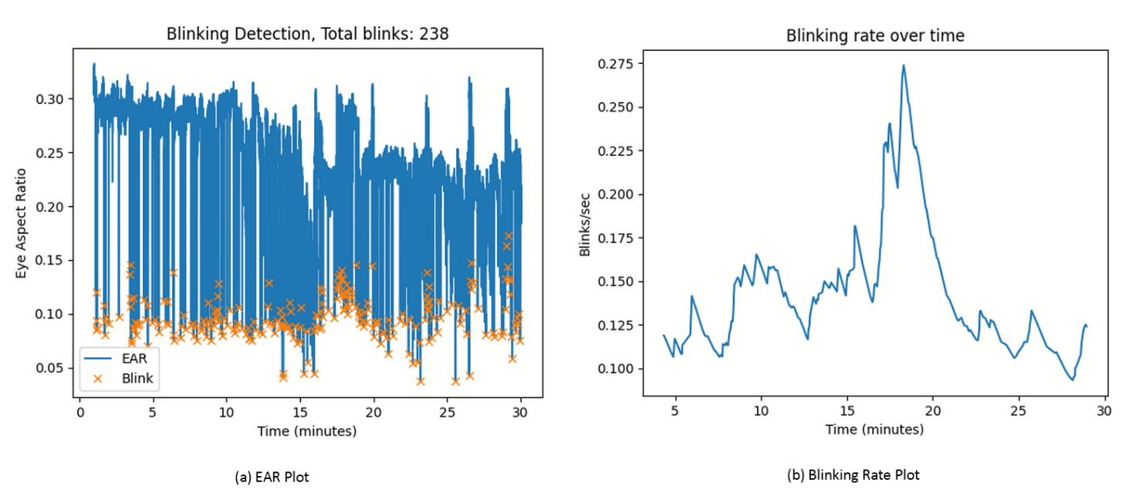

Figure 5.1.3.4: EAR and blinking rate for drowsy driver

The EAR plot in Figure 5.1.3.3 shows that the average EAR when their eyes are open roughly stays the same over the period of time as the driver remains alert. In contrast, the EAR plot in Figure 5.1.3.3 demonstrates that the average EAR decreases as the participants gets significantly drowsy. Furthermore, the blinking rate graphs suggest that participants seem to blink more frequently when they are feeling drowsy, presumably to try to stay awake.

To confirm the statistical significance and the correlation between drowsiness level and blinking rate, a two-sample t-test was performed to compare the average blinking rate for the entire session in non-drowsy participants (KSS <=6) and drowsy participants (KSS >= 7). It was found that there were some, but not significant difference in average blinking rate per minute between alert participants (Mean = 10.88, SD = 5.77) and drowsy participants (M = 15.04, SD = 11.85); t (27) = -1.20, p = 0.12. A boxplot of the distribution of the two compared groups in shown in Figure 5.1.3.5.

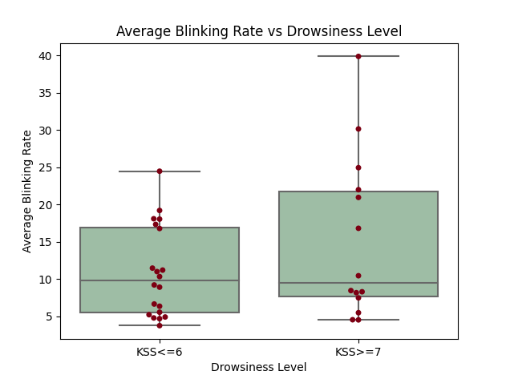

Figure 5.1.3.5: Box plot of blinking rate for alert and drowsy groups

The t-test confirms that drowsiness is correlated with an increase in blinking rate, however with a 12% chance of no correlation. Due to the limited sample size, the conclusions of the t-test may not be fully reliable. Additionally, an average blinking rate throughout the entire session may not accurately represent the driver’s state, as the blinking rate often changes over time as seen in Figure 5.1.3.3 and 5.1.3.4.

## Limitations and Future Work

### Delays in obtaining recordings

The main limitation in progressing to the Data Analysis phase, as will be explained section 6.2.1, was completing the Data Collection phase. Obtaining a full set of data for the participants that were recruited was difficult, especially for the 3-5am night recordings, since the participant was required to stay awake and remain in the lab to be monitored. Sudden disruptions in the participants’ plans delayed the recording further and due to a small sample size, it was difficult to reliably analyse and identify features in the data. Future work will include obtaining more data from more participants to increase the size of the dataset.

### Blinking and Yawning Detection inaccuracy

Due to the difference in eye aspect ratio (EAR) when the participant has their eyes open and while they blink being too small, there are inaccuracies in the determination of the blinking rate for some of the participants. The algorithm currently implemented does not adaptively adjust the EAR threshold for these cases which leads to this inaccuracy which reduces the useable nonoutlier data. More research is required to be done to improve the accuracy of the detection.

There is significant inaccuracy in the output when the yawning rate of the participants is determined due to talking during the recording. Since there was insufficient time to implement an alternate algorithm or machine learning technique that can distinguish between talking and yawning, this was not implement during this stage of the project. Further literature review will be conducted to create a more accurate system capable of distinguishing and determining the yawning rate of the participants from the recordings.

### Error in Vehicular recording files

There was an error in the program that was used to record the steering wheel, accelerometer and decelerometer data which has caused the data recorded to be unusable. Due to this setback, the recorded data steering wheel, accelerometer and brakes cannot be used directly. An alternative solution is to use the video recording of the simulator to obtain these measurements. A software that can detect the lane position is used to determine steering and the speedometer is clearly visible in the recording as well and thus computer vision techniques can be used to determine the acceleration and deceleration of the vehicle from the recording.

Another solution that has been developed is fixing the program. After fixing the program, the recordings of the investigators have been taken again and since the data collection is still under progress, future works will include finishing the remainder of the data to be recorded with the correct program.

### Future Work on Crash Detection

In some data that were recorded, the participants were able to experience extreme drowsiness (KSS-9, KSS-10) which caused them to occasionally crash their vehicles from micro sleeps. This valuable data will be further explored in future work as it would be extremely useful for detecting signs of heavy drowsiness typically preceding accidents. Physiological, behaviour and vehicular features will be analysed just before the accident time and these would be statistically compared with a control group to determine statistical significance of the selected feature.

# Scope, Project Plan & Timeline

## Project Scope

The scope of the project includes:

* Using the selected sensors for the simulator experiment to collect data from 20 participants at various times of the day.
* Using the selected sensors for the real driving experiment to collect data from 20 participants.
* Analysing the collected data and information from literature research to determine correlation between measurements and drowsiness.
* Creating Neural Network structure(s) using appropriate machine learning algorithms that can detect drowsiness close to real-time from the sensor measurements.
* Implementing the Neural Network(s) in a mobile application that can send out alerts to the driver.
* Interfacing the mobile application with the sensors that collect data.

The project will not include:

* Integrating the sensors into a physical vehicle.
* Releasing the mobile application on an app store.
* Developing EEG, ECG, EMG, and EOG sensors.
* Investigate the suitability of sensors.
* Improving the circuits and the hardware already existing.
* Testing the final system on a physical vehicle.

## Project Plan & Timeline

### Project Plan

The project aims to create a drowsiness detection and alert system for drivers and as such, the work breakdown has been divided into four phases:

* Phase 1: Research and Preparation
* Phase 2: Data Collection
* Phase 3: Data Analysis
* Phase 4: Detection System

#### Phase 1: Research and Preparation

The Research and Preparation phase consists of two main steps which are the Preparation and Project Proposal.

Preparation refers to catching up on the work completed, preparing the simulator and then the sensors. This will be considered complete when a complete set of recording of the investigators are retrieved.

The Project Proposal step refers to doing literature review, determining the methods and methodologies to be adapted for the project, and establishing the OHS and non-OHS risk assessments. This will be considered complete when the project proposal is approved.

#### Phase 2: Data Collection

The data collection phase consists of three main steps which are participants recruitment, simulation data collection and car seat sensors data collection.

The participants recruitment include advertising, obtaining gift cards and scheduling the data recordings. This step will be complete when all the participants schedule has been made and gift cards are arranged.

The simulator data collection consists of getting measurements from the vehicular, physiological, and behavioural sensors and is considered complete when the simulator experiment measurements are retrieved for all the participants.

The passenger seat data collection consists of getting the BCG and accelerometer measurements and is considered complete when it is retrieved from all the participants.

#### Data Analysis

The three steps making up the data analysis is noise filtering, simulator data analysis and passenger seat data analysis.

Noise filtering refers to pre-processing the measurements taken so that they can be ready to be inputted into machine learning algorithms to identify and extract features from the data. Simulator and Passenger seat data analysis refers to using the pre-processed data and extracting features from them. Data Analysis will be completed when the features identified in literature review are able to be extracted.

#### Phase 4: Detection System

The two steps that make up the Detection system phase are the Neural network implementation and the Software Implementation.

The Neural Network implementation refers to determining the architecture of the network, creating the datasets and training/optimization parameters and the software implementation refers to making the mobile app and the vehicle system software. This final phase will be completed when the mobile app and vehicle software system is able to detect drowsiness accurately in the driver and alert them.

### Timeline

The following Gantt chart in figure 6.2.2.1 shows the proposed timeline for the project.

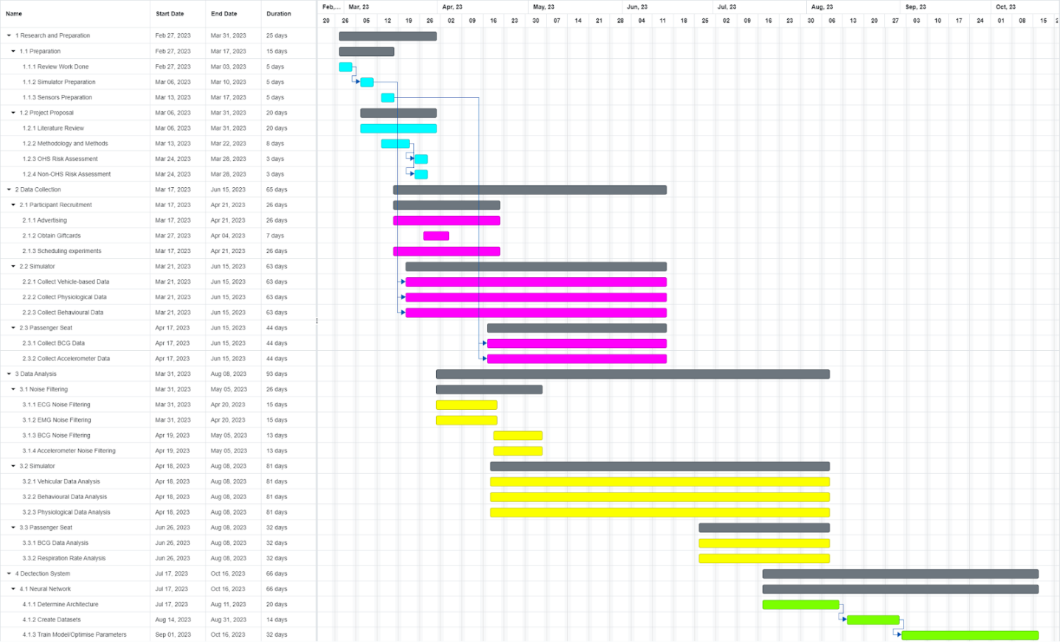

Figure 6.2.2.1: Project timeline Gantt chart

A link to a higher quality version of this Gantt chart is provided in Appendix E: Gantt Chart.

## Team Strategy and Work Breakdown

A work breakdown structure has been initially created with all the different stages of the project. These stages have been outlined from the defined project scope. The stages of the project were further broken down into smaller sections and then the different tasks related to each sub-section has been identified. This work breakdown structure has been attached in Appendix D: Work Breakdown Structure.

Following the preparation of the WBS, a responsibility matrix showing resource allocation has been created as shown in table 6.3.1. The following nomenclature is used while allocating tasks:

* A: All members of the team must contribute to or fulfill the task individually or together.
* P: The allocated team member is primarily responsible for the completion of the task.
* S: The allocated team member is secondarily responsible for the completion of the task.

Prior to the allocation of the tasks, a team contract that outlines the rules and regulations regarding expectations, communication, team meetings, team conflict and decision making, stress management, and contract code of conduct has been signed between the team members. This document is attached to Appendix B: Team Contract.

Table 6.3.1: Responsibility assignment for WBS

|  |  |  |  |
| --- | --- | --- | --- |
| **WBS Item** | **Work Item** | **Ling** | **Umar** |
| **1** | **Research and Preparation** |  |  |
| **1.1** | **Preparation** |  |  |
| 1.1.1 | Review work done | A | A |
| 1.1.2 | Simulator | A | A |
| 1.1.3 | Sensors | A | A |
| **1.2** | **Project Proposal** |  |  |
| 1.2.1 | Literature Review | A | A |
| 1.2.2 | Methodology and Methods | A | A |
| 1.2.3 | OHS Risk Assessment | P |  |
| 1.2.4 | Non-OHS Risk Assessment |  | P |
| **2** | **Data Collection** |  |  |
| **2.1** | **Participant Recruitment** |  |  |
| 2.1.1 | Advertising | S | P |
| 2.1.2 | Obtain Gift cards | P |  |
| 2.1.3 | Scheduling |  | P |
| **2.2** | **Simulator** |  |  |
| 2.2.1 | Vehicle-based |  | P |
| 2.2.2 | Physiological based |  | P |
| 2.2.3 | Behavioural based |  | P |
| **2.3** | **Passenger seat** |  |  |
| 2.3.1 | BCG | P |  |
| 2.3.2 | Accelerometer | P |  |
| **3** | **Data Analysis** |  |  |
| **3.1** | **Noise Filtering** |  |  |
| 3.1.1 | ECG | P | S |
| 3.1.2 | EMG | P |  |
| 3.1.3 | BCG |  | P |
| 3.1.4 | Accelerometer |  | P |
| **3.2** | **Simulator** |  |  |
| 3.2.1 | Vehicular Data Analysis | S | P |
| 3.2.2 | Behavioural Data Analysis | P |  |
| 3.2.3 | Physiological Data Analysis | A | A |
| **3.3** | **Passenger Seat** |  |  |
| 3.3.1 | BCG Analysis | P |  |
| 3.3.2 | Respiration Rate Analysis | P | S |
| **4** | **Detection System** |  |  |
| **4.1** | **Neural Network** |  |  |
| 4.1.1 | Determine Architecture | P | S |
| 4.1.2 | Create Dataset | S | P |
| 4.1.3 | Train Model/Optimize Parameter | A | A |
| **4.2** | **Software Implementation** |  |  |
| 4.2.1 | Mobile App | A | A |
| 4.2.2 | Vehicle System | A | A |

# Risk Management Plan

A comprehensive risk assessment plan is a critical document that helps to identify, evaluate, and prioritize risks that would inhibit the success and deliverance of the project. The Gantt chart in figure 5.2.1 outlines the project tasks, with each task being dependent on its predecessor. Failure to complete any of the predecessor tasks will result in delays to subsequent tasks' completion. It is, therefore, imperative to ensure timely completion and to make them robust to potential failure. Table 6.1 details the non-OHS risks that should be considered. A complete risk assessment of OHS risks is attached in Appendix A: Project Risk Assessment for reference.

Table 7.1: Non-OHS Risk Assessment

|  |  |  |  |  |  |  |
| --- | --- | --- | --- | --- | --- | --- |
| **Project Risk** | **Risk** | **Likelihood** | **Consequence** | **Risk  level** | **Mitigation** | **Residual Risk** |
| Communication errors between team members and supervisor | Tasks may be incorrectly done due to misunderstanding expectations | Possible | Serious | M | Clarify with supervisor on points of confusion of the project.  Maintain a clear communication channel between team members that is always open.  Conduct regular meetings with all team members and supervisor to prevent confusion. | Delayed project deliverables and progressing work |
| Skewed workload distribution due to improper scheduling/timelining. | May cause dissatisfaction of team members and delay the work allocated to them | Possible | Minor | M | Produce a realistic and proper Gantt chart and assign task responsibilities.  Maintain communication between teammates and work together to ensure everyone knows the deadline of tasks. | Delayed completion of workload distribution and Gantt chart preparation |
| Loss/damage to personal devices due to improper handling leading to loss to project files and data. (Physical damage and software damage from malware) | Delayed analysis of participant data and may need to recollect data | Unlikely | Serious | M | Backup the files in Google Drive to prevent the loss of data.  Avoid downloading files or clicking on links from untrustworthy websites, and to maintain secure and up-to-date passwords. | Must have stable internet connection to be able to use the data stored in Google Drive |
| Loss/damage of sensor equipment due to improper handling | Unable to collect required data for analysis on time | Unlikely | Disastrous | M | Keep equipment within a protective bag/case when moving it around.  Use appropriate power supply so electronics do not get damaged.  Contact unit coordinators for replacements immediately to prevent further project delays. | May have additional costs related to transporting and storing the sensors and that may strain the budget to be spent on other parts. |
| Some team members getting sick, therefore unable to work | Delayed completion of tasks allocated to sick team members | Likely | Minor | M | Make sure everyone on the team understands all components of the project, so that if one person is unable to work, the completion of the project isn’t significantly affected.  Achieve this through regular group meetings and communication. | May have a lack of expertise in certain areas that are critical to the project's success may cause the need to rely on external resources, which could result in delays. |
| Inability to recruit enough participants for data collection | Delayed collection and analysis of data | Possible | Serious | M | Post ads into FYP forums to try and recruit people and offer then vouchers for volunteering to participate | People may still be unwilling to volunteer |
| Inability to find suitable noise filtering techniques for data | Delayed analysis of data or incorrect analysis of data | Unlikely | Serious | M | Work with knowledgeable people to create a novel filtering method.  Research filtering methods to expand our knowledge of available filters | Unable to still create a high-quality filter that works properly leading to spending more time to get the system to work in the real world |
| Inability to find suitable machine learning methods for the data | Delayed creation of software system for drowsiness detection | Possible | Serious | M | Research mentions of proper and working Neural Network architectures in literature | May require expert math knowledge which may also require more time to be invested into learning algorithms, in turn, delaying project |

This project has been approved by the Monash University Human Research Ethics Committee (MUHREC). Table 6.2 details the main ethics related risks that may be present in this project.

Table 6.2: Ethics related risks

|  |  |  |  |  |  |  |
| --- | --- | --- | --- | --- | --- | --- |
| **Project Ethic Risk** | **Risk** | **Likelihood** | **Consequence** | **Risk  level** | **Mitigation** | **Residual Risk** |
| Not getting Informed consent from all participants | May have legal repercussions if the participant does not want their data collected or used in a certain way | Possible | Serious | M | Provide a printed consent form to all participants to complete before doing any data collection of the individual. Make sure the consent form informs the participant of all aspects of the project that may affect them. | Participants may still misunderstand or change their minds about data usage, leading to potential legal repercussions. |
| Improper handling of data containing Personally Identifiable Information (PII) | May lead to violation of data protection laws and lead of legal penalties and termination of project.  May lead to severe consequences from identity theft from leaked data | Unlikely | Serious | M | Collected data will be kept strictly within the research team.  Measures will be taken to anonymize data where possible.  Face data will only be published with the written consent of participants | There may be security breaches or unauthorized access leading to potential violations of data protection laws and severe consequences like identity theft. |
| Experiments may cause psychological impacts due to previous driving related trauma | May induce serious mental harm to individuals, resulting in termination of project. | Unlikely | Serious | M | Inform participants of such psychological risks within the consent form  Provide participants with mental help resources if they experience signs of trauma or distress | Participants may still experience serous mental harm despite the resources and information provided |
| The drowsiness detection system may not work equally well, or may not be accessible to all individuals, regardless of race and gender | May cause increased social inequality and health disparity. | Possible | Serious | M | Collection of data from a wide variety of participants from all genders and demographics. | There may still be a risk of increased social inequality and health disparity due to factors beyond the scope of data collection, such as systemic biases and socioeconomic disparities |

# Sustainability Plan

Sustainable engineering refers to the practice of designing and developing engineering solutions that meet present needs without compromising the ability of future generations to meet their own needs. This uses a concept that is called the triple bottom line which emphasizes the consideration of three connected dimensions which are economic viability, environmental protection and social equity.

This project of detecting drowsiness in drivers and creating an alarm system strongly relates to the UN SDG 3 which is Good Health and Well-being. More specifically, it enforces target 3.6 of this goal which is: ‘By 2020, halve the number of global deaths and injuries from road traffic accidents.’ The key indicator for this target is measuring the number of road traffic accidents per 100,000 population. The leading cause of death for people between 15 and 29 years of age is road traffic accidents. By developing a system that can detect drowsiness in drivers, the project can help reduce the number of accidents caused by fatigue-related incidents, thereby improving road safety. It helps prevent injuries and saves lives, aligning with the goal of reducing the global burden of injuries and deaths.

The project plan, process, outcomes, and implications, hence, should bear sustainable engineering considerations at its core. For example, the use of environment friendly technologies such as energy-efficient rechargeable batteries and can help ensure accessibility, affordability, and sustainability of the system to benefit a wide range of users. By enhancing road safety, the system contributes to a more sustainable transportation system. Additionally, if the system is designed to be affordable and accessible, it can reach a broader population, including low-income communities, making road safety advancements more equitable. Finally, by reducing road traffic accidents and injuries, the project contributes to the conservation of human life, an essential aspect of sustainability.

When looking at the environmental consequences, the positive impacts include reducing the number of road traffic accidents caused by drowsy driving. The negatives would include the impact of producing the drowsiness detection system, including resource extraction, energy consumption, and waste generation.

For the social consequences, the project aims to enhance road safety, which has significant social benefits. It can prevent injuries, fatalities, and the associated physical and emotional trauma for drivers, passengers, and pedestrians. However, privacy concerns may arise as the project involves monitoring and analyzing personal data to detect drowsiness and to address these, transparency, consent, and strong data protection measures are in place to address potential social implications and maintain public trust.

Finally, when analysis the economic consequences, the project can have positive economic impacts by reducing the financial burden associated with road accidents. Fewer accidents mean reduced costs related to healthcare, emergency services, vehicle repairs, insurance claims, and productivity losses. Conversely, implementation of the drowsiness detection system would involve initial costs, including research and development, system integration, and infrastructure requirements.

The stakeholders for this project are the road users, the local communities, transportation authorities and policymakers, and automobile manufacturers and technology providers. They must also be considered for sustainability, and this can be done by promoting inclusive engagement, transparent communication, and long-term partnerships. By considering these stakeholder groups and incorporating their perspectives into the project's design, implementation, and evaluation, the sustainability of the project can be enhanced.

The project on detecting drowsiness in drivers and an alarm system exemplifies a sustainable approach by considering the triple bottom line and actively incorporating environmental, social, and economic considerations. By promoting road safety, minimizing environmental impact, prioritizing stakeholder engagement, and fostering economic value, the project works towards a more sustainable and resilient future for all.

# References

|  |  |
| --- | --- |
| [1] | Centers for Disease Control and Prevention, “Drowsy Driving: Asleep at the Wheel,” CDC, 18 November 2022. [Online]. Available: https://www.cdc.gov/sleep/features/drowsy-driving.html#print. [Accessed 3 April 2023]. |
| [2] | D. Dawson and K. Reid, “Fatigue, alcohol and performance impairment,” *nature,* vol. 388, pp. 235-237, 1997. |
| [3] | N. Watson, T. Morgenthaler, R. Chervin, K. Carden, D. Kirsch, D. Kristo, R. Malhotra, J. Martin, K. Ramar, I. Rosen, T. Weaver and M. Wise, “Confronting Drowsy Driving: The American Academy of Sleep Medicine Perspective,” *Journal of Clinical Sleep Medicine,* vol. 11, no. 11, pp. 1335-1336, 2015. |
| [4] | S. Arun, S. Kenneth and M. Murugappan, “Detecting Driver Drowsiness Based on Sensors: A Review,” *Sensors,* vol. 12, no. 12, p. 16937–16953, 2012. |
| [5] | T. S. Manchanda, G. Singh and S. N. Singh, “Driver Drowsiness Detection using AI Techniques,” in *2021 9th International Conference on Reliability, Infocom Technologies and Optimization*, Noida, India, 2021. |
| [6] | S. Nordbakke and F. Sagberg, “Sleepy at the wheel: Knowledge, symptoms and behaviour among car drivers,” *Transportation Research Part F: Traffic Psychology and Behaviour,* vol. 10, no. 1, pp. 1-10, 2007. |
| [7] | M. Ramzan, H. U. Khan, S. M. Awan, A. Ismail, M. Ilyas and M. A, “A Survey on State-of-the-Art Drowsiness Detection Techniques,” *IEEE Access,* vol. 7, pp. 61904-61919, 2019. |
| [8] | S. Otmani, T. Pebayle, J. Roge and A. Muzet, “Effect of driving duration and partial sleep deprivation on subsequent alertness and performance of car drivers,” *Physiol,* vol. 84, pp. 715-724, 2005. |
| [9] | F. Ruijia, Z. Guangyuan and C. Bo, “An on-Board System for Detecting Driver Drowsiness Based on Multi-Sensor Data Fusion Using Dempster-Shafer Theory,” in *International Conference on Networking, Sensing and Control*, Okayama, Japan, 2009. |
| [10] | E. Vural, “Video based detection of driver fatigue,” Sabanci University, Istanbul, Turkey, 2009. |
| [11] | M. Ingre, T. ÅKerstedt, B. Peters, A. Anund and G. Kecklund, “Subjective sleepiness, simulated driving performance and blink duration: Examining individual differences,” *J. Sleep Res,* vol. 15, pp. 47-53, 2006. |
| [12] | R. Simons, M. Martens, J. Ramaekers, A. Krul, I. Klöpping-Ketelaars and G. Skopp, “ Effects of dexamphetamine with and without alcohol on simulated driving,” *Psychopharmacology ,* vol. 222, pp. 391-399, 2012. |
| [13] | Y. Albadawi, M. Takruri and M. Awad, “A Review of Recent Developments in Driver Drowsiness Detection Systems,” *sensors,* vol. 22, no. 5, pp. 2069-2109, 2022. |
| [14] | M. T. Khan, H. Anwar, F. Ullah, A. U. Rehman, R. Ullah, A. Iqbal, B.-H. Lee and K. S. Kwak, “Smart Real-Time Video Surveillance Platform for Drowsiness Detection Based on Eyelid Closure,” *Wireless Communications and Mobile Computing,* vol. 2019, p. 9, 2019. |
| [15] | W.-B. Horng, C.-Y. Chen, Y. Chang and H.-C. Fan, “Driver fatigue detection based on eye tracking and dynamic template matching,” in *IEEE International Conference on Networking, Sensing and Control*, Taipei, Taiwan, 2004. |
| [16] | C. B. S. Maior, M. J. d. C. Moura, J. M. M. Santana and I. D. Lins, “Real-time classification for autonomous drowsiness detection using eye aspect ratio,” *Expert Systems with Applications,* vol. 158, pp. 113505-113516, 2020. |
| [17] | A. Rahman, M. Sirshar and A. Khan, “Real time drowsiness detection using eye blink monitoring,” in *2015 National Software Engineering Conference (NSEC)*, Rawalpindi, Pakistan, 2015. |
| [18] | M. Saradadevi and P. Bajaj, “Driver Fatigue Detection Using Mouth and Yawning Analysis,” *IJCSNS International Journal of Computer Science and Network Security,* vol. 8, no. 6, pp. 183-188, 2008. |
| [19] | M. Knapik and B. Cyganek, “Driver’s fatigue recognition based on yawn detection in thermal images,” *Neurocomputing,* vol. 338, pp. 274-292, 2019. |
| [20] | S. Hu and G. Zheng, “Driver drowsiness detection with eyelid related parameters by support vector machine,” *Exp. Syst. Appl,* vol. 36, pp. 7651-7658, 2009. |
| [21] | W. Liang, J. Yuan, D. Sun and M. Lin, “Changes in physiological parameters induced by indoor simulated driving: Effect of lower body exercise at mid-term break,” *Sensors,* vol. 9, pp. 6913-6933, 2009. |
| [22] | R. N. Khushaba, S. Kodagoda, S. Lal and G. Dissayanake, “Driver drowsiness classification using fuzzy wavelet-packet-based feature-extraction algorithm,” *IEEE Trans. Biomed. Eng,* vol. 58, pp. 121-131, 2011. |
| [23] | M. Patel, S. Lal, D. Kavanagh and P. Rossiter, “Applying neural network analysis on heart rate variability data to assess driver fatigue,” *Exp. Syst. Appl.,* vol. 38, pp. 7235-7242, 2011. |
| [24] | I. Sadek, J. Biswas and B. Abdulrazak, “Ballistocardiogram signal processing: a review,” *Health Information Science and Systems,* vol. 7, no. 1, pp. 10-32, 2019. |
| [25] | M. Akin, M. Kurt, N. Sezgin and M. Bayram, “Estimating vigilance level by using EEG and EMG signals,” *Neural Computing and Applications,* vol. 17, no. 3, pp. 227-236, 2008. |
| [26] | V. Balasubramanian and K. Adalarasu, “EMG-based analysis of change in muscle activity during simulated driving,” *Journal of Bodywork and Movement Therapies,* vol. 11, no. 2, pp. 151-158, 2007. |
| [27] | P. Hung, “Estimating respiration rate using an accelerometer sensor,” in *Proceedings of the 8th International Conference on Computational Systems-Biology and Bioinformatics*, New York, USA, 2017. |
| [28] | M. Babaeian, N. Bhardwaj, B. Esquivel and M. Mozumdar, “Real time driver drowsiness detection using a logistic-regression-based machine learning algorithm,” in *2016 IEEE Green Energy and Systems Conference (IGESC)*, Long Beach, CA, USA, 2016. |
| [29] | A. Kumar and R. Patra, “Driver drowsiness monitoring system using visual behaviour and machine learning,” in *2018 IEEE Symposium on Computer Applications & Industrial Electronics (ISCAIE)*, Penang, Malaysia, 2018. |
| [30] | M. Ngxande, J. Tapamo and M. Burke, “Driver drowsiness detection using behavioral measures and machine learning techniques: A review of state-of-art techniques,” in *2017 Pattern Recognition Association of South Africa and Robotics and Mechatronics (PRASA-RobMech)*, Bloemfontein, South Africa, 2017. |
| [31] | V. R. R. Chirra, S. R. Uyyala and V. K. K. Kolli, “Deep CNN: A Machine Learning Approach for Driver Drowsiness Detection Based on Eye State,” *International Information and Engineering Technology Association,* vol. 33, no. 6, pp. 461-466, 2019. |
| [32] | M. M. Hasan, C. N. Watling and G. S. Larue, “Physiological signal-based drowsiness detection using machine learning: Singular and hybrid signal approaches,” *Jounral of Safety Research,* vol. 80, pp. 215-222, 2022. |
| [33] | A. A. Redhaei, Y. Albadawi, S. Mohamen and A. A, “Realtime Driver Drowsiness Detection Using Machine Learning,” in *2022 Advances in Science and Engineering Technology International Conferences (ASET)*, Dubai, United Arab Emirates, 2022. |
| [34] | V. Yarlagadda, S. G. Koolagudi, M. Kumar and S. Donepudi, “Driver Drowsiness Detection Using Facial Parameters and RNNs with LSTM,” in *2020 IEEE 17th India Council International Conference (INDICON)*, New Delhi, India, 2020. |
| [35] | OpenBCI, “Setting up for EEG, EMG, and ECG at the same time,” OpenBCI, 12 September 2021. [Online]. Available: https://docs.openbci.com/GettingStarted/Biosensing-Setups/ExGSetup/. [Accessed 3 April 2023]. |
| [36] | automaticaddison, “The Ultimate Guide to Real-Time Lane Detection Using OpenCV,” 12 April 2021. [Online]. Available: https://automaticaddison.com/the-ultimate-guide-to-real-time-lane-detection-using-opencv/. [Accessed May 2023]. |
| [37] | joefernandez, “MediaPipe Face Mesh,” 4 April 2023. [Online]. Available: https://github.com/google/mediapipe/blob/master/docs/solutions/face_mesh.md. [Accessed May 2023]. |
| [38] | Aman and A. L. Sangal, “Drowsy Alarm System Based on Face Landmarks Detection Using MediaPipe FaceMesh,” in *Proceedings of First International Conference on Computational Electronics for Wireless Communications*, 2022. |
| [39] | M. Team, “canonical_face_model_uv_visualization.png,” 16 September 2020. [Online]. Available: https://github.com/google/mediapipe/blob/a908d668c730da128dfa8d9f6bd25d519d006692/mediapipe/modules/face_geometry/data/canonical_face_model_uv_visualization.png. [Accessed May 2023]. |
| [40] | C. Dewi, C. R, C. Chang, S. Wu, X. Jiang and H. Yu, “Eye Aspect Ratio for Real-Time Drowsiness Detection to Improve Driver Safety,” *electronics,* vol. 11, no. 19, p. 3183, 2022. |
| [41] | A. Kuwahara, K. Nishikawa, R. Hirakawa, H. Kawano and Y. Nakatoh, “Eye fatigue estimation using blink detection based on Eye Aspect Ratio Mapping(EARM),” *Cognitive Robotics,* vol. 2, pp. 50-59, 2022. |
| [42] | M. Dua, Shakshi, R. Singla, S. Raj and A. Jangra, “Deep CNN models-based ensemble approach to driver drowsiness detection,” *Neural Computing and Applications,* vol. 33, pp. 3155-3168, 2021. |
| [43] | S. Anber, W. Alsaggaf and W. Shalash, “A Hybrid Driver Fatigue and Distraction Detection Model Using AlexNet Based on Facial Features,” *electronics,* vol. 11, no. 2, p. 285, 2022. |
| [44] | Q. Massoz, T. Langhor, C. Francois and J. Verly, “The ULg multimodality drowsiness database (called DROZY) and examples of use,” in *2016 IEEE Winter Conference on Applications of Computer Vision (WACV)*, Lake Placid, NY, USA, 2016. |
| [45] | C. Weng, Y. Lai and S. Lai, “Driver Drowsiness Detection via a Hierarchical Temporal Deep Belief Network,” in *Asian Conference on Computer Vision*, 2017. |
| [46] | E. Perkins, C. Sitaula, M. Burke, J. Manousakis, C. Anderson and F. Marzbanrad, “Investigating Physiological and Behavioural Sensing Modalities Towards Drowsiness Detection,” *IEEE SENSORS JOURNAL,* 2017. |

# Appendices

## Appendix A: Project Risk Assessment

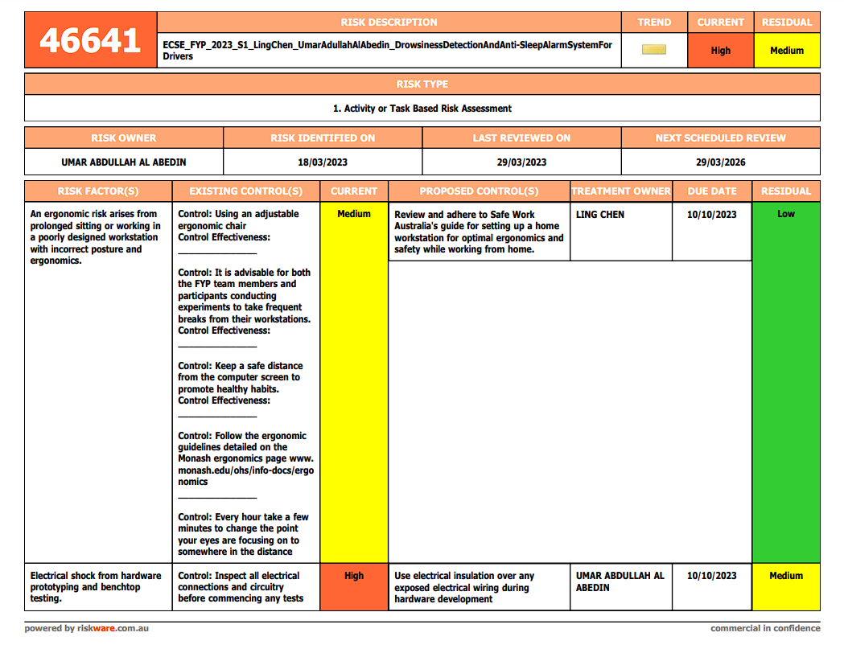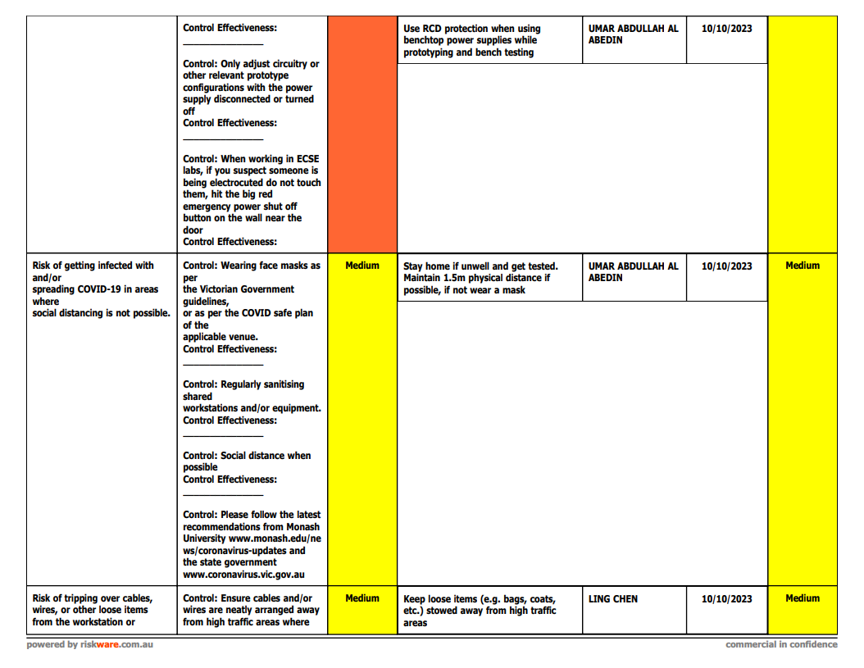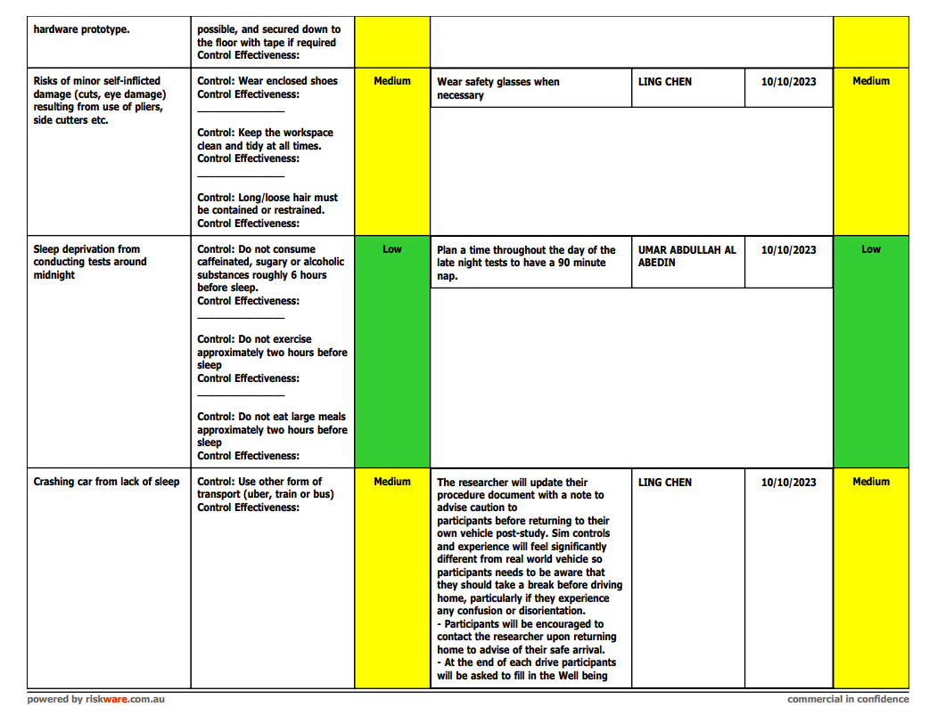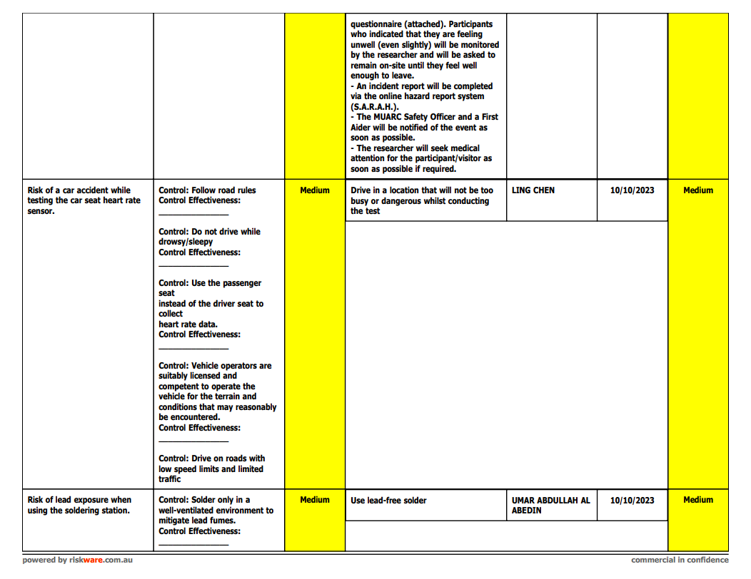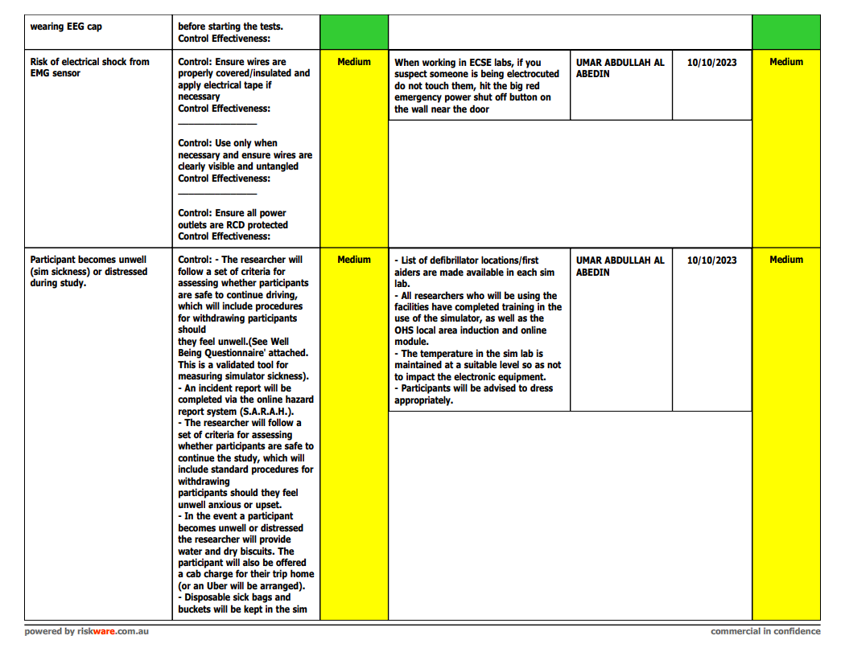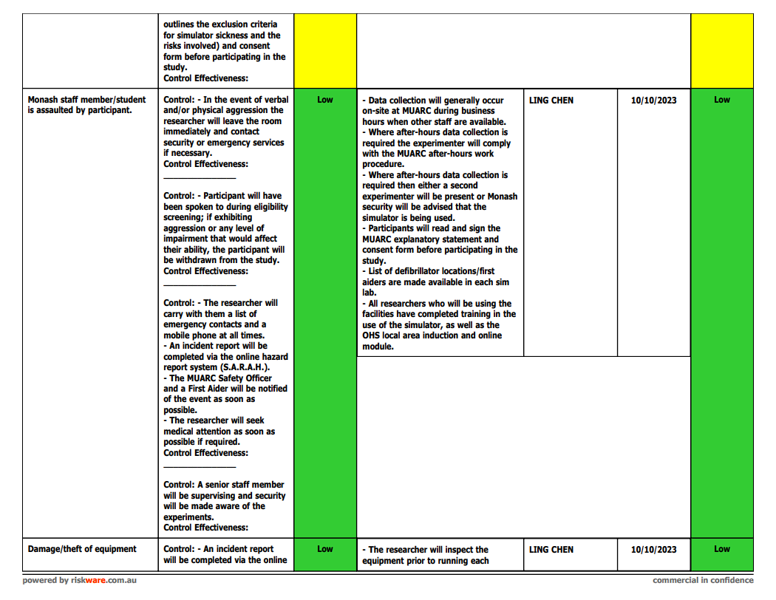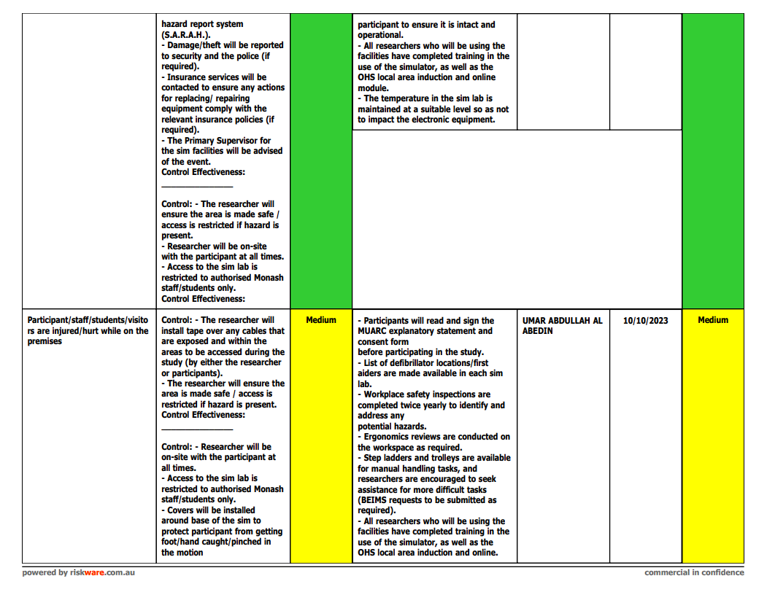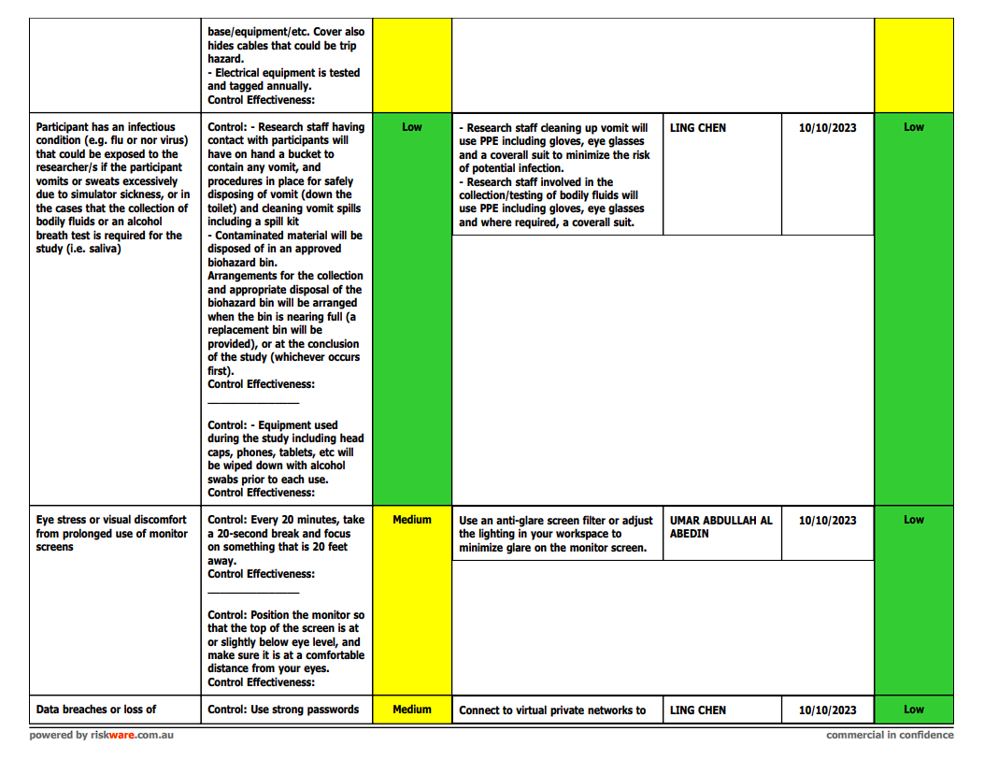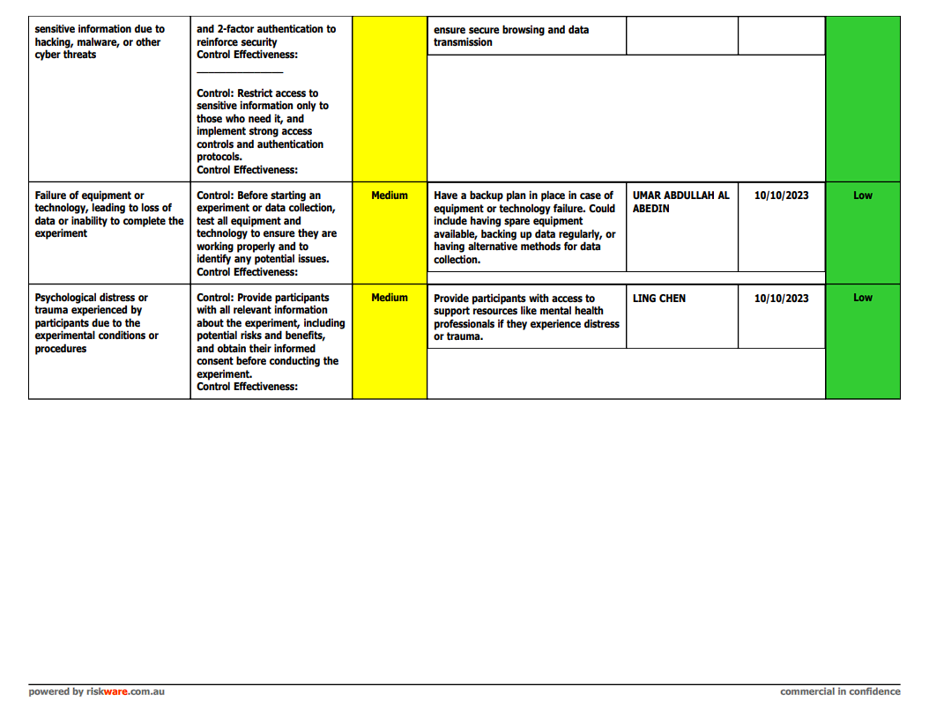

## Appendix B: Team Contract and Meeting Minutes

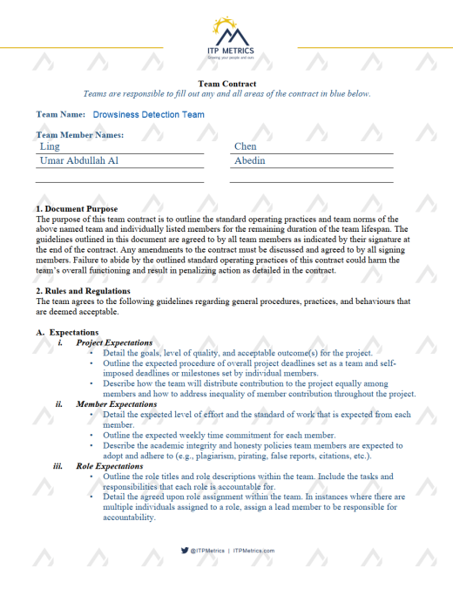



## Appendix C: Simulator Settings

### Config.cfg

uset s_reverb_world "1"

uset s_reverb_cabin "1"

uset s_noise_aero "1"

uset s_noise_windows "1"

uset s_rumble_enabled "1"

uset s_reverse_enabled "1"

uset s_cb_radio_beep_type "roger01"

uset s_cb_radio_beep_own "0"

uset s_cb_radio_beep_enabled "1"

uset s_cb_radio_noise_enabled "1"

uset g_mp_name_tags "1"

uset g_chat_fade_out_timer "5"

uset g_chat_partial_fade_out "0"

uset g_chat_on_navigation "1"

uset g_chat_activate "1"

uset g_chat_close_automatic "0"

uset g_disable_beacons "0"

uset g_show_game_blockers "1"

uset g_show_game_elements "1"

uset g_hmd_no_3d_background "0"

uset g_hmd_no_special_menu "0"

uset g_hmd_reduced_cabin_movement "1"

uset g_hmd_no_artifical_movement "0"

uset g_eye_pause_gaze "3000"

uset g_eye_pause "0"

uset g_cam_blinker "0"

uset g_cam_physics_value "1.0"

uset g_cam_physics "1"

uset g_blinker_auto_off "1"

uset g_cruise_control_smart "5.0"

uset g_cruise_control_grid "5.0"

uset g_adaptive_shift "0.0"

uset g_fuel_simulation "0"

uset g_hardcore_simulation "0"

uset g_reg_setting ""

uset g_brake_light_all "0"

uset g_use_speed_limiter "1"

uset g_hud_speed_warning "-1"

uset g_hud_speed_limit "1"

uset g_axle_drop_auto "1"

uset g_engine_start_auto "1"

uset g_motor_brake_auto "0"

uset g_retarder_auto "0"

uset g_cabin_suspension_stiffness "0.75"

uset g_suspension_stiffness "0.74"

uset g_trailer_stability "0.5"

uset g_truck_stability "0.5"

uset g_mpg "0"

uset g_gallon "0"

uset g_fahrenheit "0"

uset g_pounds "kg"

uset g_mph "0"

uset g_road_events "0.45"

uset g_detours "0.3364"

uset g_name_localization_secondary "0"

uset g_name_localization "1"

uset g_lang_set "1"

uset g_lang "en_us"

uset g_cutscenes "0"

uset g_phys_mirrors "0"

uset g_world_map_zoom "7"

uset g_cargo_load_require_park_brake "0"

uset g_cargo_load_require_engine_off "1"

uset g_show_always_wotr_event "0"

uset g_last_wotr_event_start "0"

uset g_multiplayer_backup_index "-1"

uset g_force_load_selector "-1"

uset g_autoload_ignore_autosave "0"

uset g_start_in_truck "0"

uset g_park_brake_init "0"

uset g_trailer_advanced_coupling "0"

uset g_parking_difficulty "1"

uset g_simple_parking_doubles "1"

uset g_speed_warning "0"

uset g_voice_navigation_pack ""

uset g_voice_navigation "0"

uset g_job_distance "0.2"

uset g_job_distance_limit "-1.0"

uset g_income_factor "5"

uset g_currency "0"

uset g_bad_weather_factor "0.41"

uset g_truck_analysis_fold "0"

uset g_desktop_rnd "0"

uset g_desktop_bcg "config"

uset g_save_idx "1"

uset g_ui_map_align "1"

uset g_gps_routing_mode "0"

uset g_gps_navigation "3"

uset g_heavy_cargo_popup "0"

uset g_mirrors "1"

uset g_adviser_eta "1"

uset g_adviser_running_message "1"

uset g_adviser_auto_parking "0"

uset g_adviser_keep_hidden "0"

uset g_adviser "1"

uset g_desktop_tutorial "0"

uset g_tutorial "0"

uset g_fatigue "0"

uset g_time_zones "0"

uset g_police "0"

uset g_subtitles "0"

uset g_clock_24 "1"

### Config_local.cfg

uset s_cbeffects_mute "0"

uset s_voiceover_mute "0"

uset s_intro_music_mute "0"

uset s_ui_music_mute "0"

uset s_ui_mute "0"

uset s_navigation_mute "0"

uset s_music_mute "0"

uset s_radio_mute "0"

uset s_interior_mute "0"

uset s_ambient_mute "0"

uset s_world_mute "0"

uset s_traffic_mute "0"

uset s_trailer_mute "0"

uset s_truck_noise_mute "0"

uset s_truck_effects_mute "0"

uset s_truck_turbo_mute "0"

uset s_truck_exhaust_mute "0"

uset s_truck_engine_mute "0"

uset s_master_mute "0"

uset s_cbeffects_volume "0"

uset s_voiceover_volume "0"

uset s_intro_music_volume "0"

uset s_ui_music_volume "0"

uset s_ui_volume "0"

uset s_navigation_volume "0.26"

uset s_music_volume "0"

uset s_radio_volume "0"

uset s_interior_volume "0.25"

uset s_ambient_volume "0.26"

uset s_world_volume "0.25"

uset s_traffic_volume "0.25"

uset s_trailer_volume "0.24"

uset s_truck_noise_volume "0.24"

uset s_truck_effects_volume "0.23"

uset s_truck_turbo_volume "0.22"

uset s_truck_exhaust_volume "0.22"

uset s_truck_engine_volume "0.23"

uset s_master_volume "0.29"

uset i_oculus_eye_protrusion "0.09"

uset i_oculus_eye_height "0.15"

uset i_hmd_max_prediction "0.1"

uset i_hmd_min_prediction "0.0"

uset r_interior "1"

uset r_steering_wheel "1"

uset g_eye_preset_5 ""

uset g_eye_preset_4 ""

uset g_eye_preset_3 ""

uset g_eye_preset_2 ""

uset g_eye_preset_1 ""

uset g_eye_enable "0"

uset g_cam_window_block "0.0"

uset g_toy_physics "1"

uset g_cam_steering_reverse "1.0"

uset g_cam_steering_value "1.26"

uset g_cam_steering "1"

uset g_pedal_clutch_range "1.0"

uset g_brake_intensity "1.33061"

uset g_steer_anim_range "900"

uset g_steer_autocenter "1"

uset g_clutch_brake "0.0"

uset g_hshifter_synchronized "1"

uset g_hshifter_split "3"

uset g_hshifter_layout_shifting "1"

uset g_hshifter_layout "splitter"

uset g_trans "3"

uset g_baked_vehicle "1"

uset g_force_economy_reset "0"

uset g_input_configured "1"

## Appendix D: Work Breakdown Structure

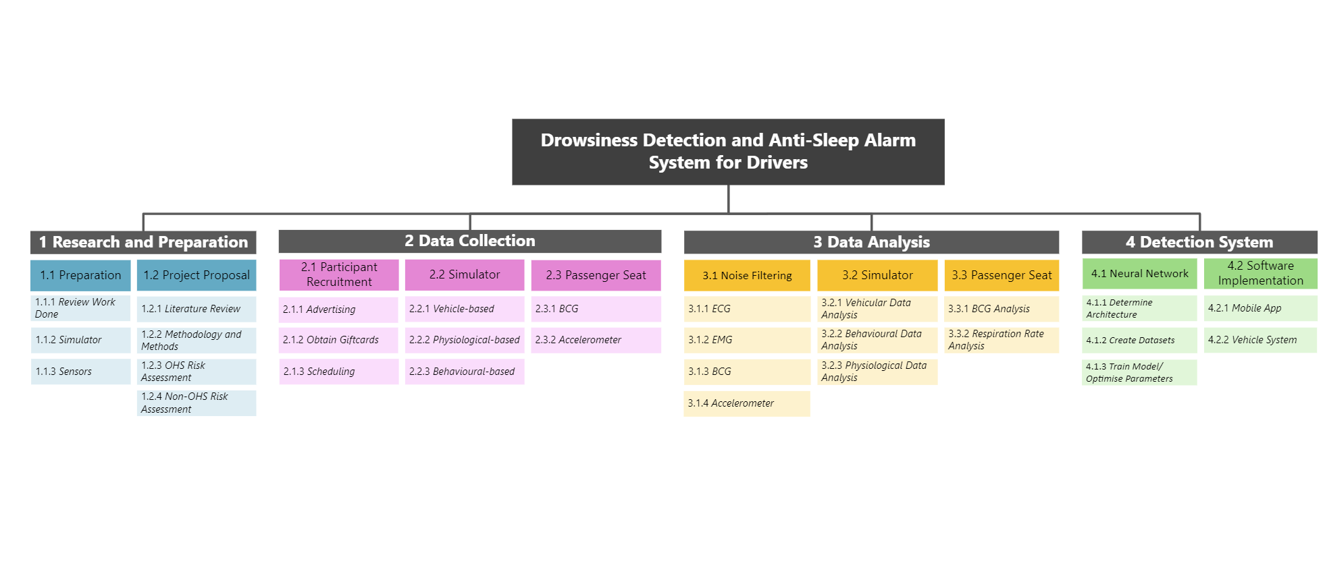

## Appendix E: Gantt Chart

The following link contains a higher resolution version of the project timeline Gantt chart.

<https://docs.google.com/spreadsheets/d/1yoKlu_y9LrbECm9yir1HmLT40wA0YhZ2qujN_qsRzHM/edit?usp=sharing>

## Appendix F: AI Statement

